ISI Reviewers' Manual

Table of contents
Guidelines for Reviewers of Informing Science Institute Journals and Conferences 4
Your Role and Responsibilities as an ISI Reviewer 4
PART I: LET’S HELP EACH OTHER BECOME EVEN BETTER RESEARCHERS 4
The ISI philosophy 5
Who are all these people and how did I get assigned to review this particular paper? 5
Your role as an ISI reviewer is special – as a mentor, guide, and coach 5
Part II: Getting to Know the ISI Paper Review System 6
Role 1: Promptly read the paper assigned to you. 6
OOPS! I WAS ASSIGNED A PAPER WHEN I AM UNAVAILABLE 8
While you can’t pick and choose which papers to review, you do choose when you will and won’t be assigned to review 9
ROLE 2: ENTERING YOUR SUGGESTIONS ONLINE USING THE ISI REVIEW SYSTEM 9
Step 1: Log in (using the link in your email or at http://My.InformingScience.org and, under Pending Review Tasks, click the name of the paper. 9
Step 2. Enter your suggestions. 10
Your feedback to the Editor 10
Carrying Out a Review Step-by-Step 11
Examples of Constructively Worded Comments 12
We Provide You with Feedback! 12
System won't let you submit your review? 14
How to let the system know that you will be unavailable, limit the number of papers assigned, resign from the board, or volunteer to do more reviewing. 14
Thank you! 15

Guidelines for Reviewers of Informing Science Institute Journals and Conferences

Guidelines for Reviewers
of Informing Science Institute Journals and Conferences
Download Manual as Docx file
Congratulations on your appointment to serve as a Reviewer on the International Review Board for an Informing Science Institute (ISI) journal. Please read and save this document because it describes your duties as an ISI Reviewer. The first part brings us all on the same page about the Informing Science Institute’s philosophy on the review process as a mentoring one. The second part deals with features of the ISI Paper Review system.

Your Role and Responsibilities as an ISI Reviewer
As mentioned above, there are two parts to your role:
- Promptly read the paper assigned to you and think about how the author might make it even better.
- Use the online review form to convey to the author (and the Editor) your thoughts, phrasing your constructive suggestions for the author as suggestions for improvements.

PART I: LET’S HELP EACH OTHER BECOME EVEN BETTER RESEARCHERS

PART I: LET’S HELP EACH OTHER BECOME EVEN BETTER RESEARCHERS

You are Part of the Solution, Fixing the Problems with Paper Reviewing
We created the ISI Paper Review System because of problems we saw in how most journals review submissions.
Problem: Slow and Tardy Replies. Have you ever submitted a paper to a journal, and didn’t hear about the review for the better part of a year or even longer? We have.
Problem: Feedback Isn’t Helpful. Have you ever received a decision letter that left you wondering how to proceed? Perhaps that decision letter contained contradictory or irrational guidance. We have.
We designed the paper review system for ISI journals to overcome these and many other problems in the typical journal peer review process. Instead of the old production model (reject defects), we at ISI journals use a continual process improvement model. While fewer than half of the papers submitted make it into print, we view our role as mentor to all authors, sharing with them our wisdom and the wisdom of our reviewers, to assist them in improving their submission. Most papers that we do publish undergo several rounds of revisions.
We also designed the system to avoid the problem of delayed reviewing of manuscripts. We endeavor to get back to authors with our initial assessment within two months of their submission. To do this, we have abandoned the model of asking Reviewers to accept assignments. Reviewers are expected to review papers assigned to their care. (See below for how to set periods of non-availability.)
You, as an ISI Reviewer, are vital to this improved way to review submissions. This manual gets us all on the same page by informing you about the ISI philosophy of the paper review process and sharing with you how to use the automated ISI Paper Review system to do your part.

The ISI philosophy
As a Reviewer for an ISI journal, your principal role is as a mentor to the author. This mentoring by you and your fellow reviewers makes ISI a constructive force in academia higher education and beyond.
Your crucial role is that of an agent for improving research and researchers. While other journals ask for gatekeepers, your role is of a guide. While other journals ask for referees, your role is of the coach. At ISI, we all help each other. Reviewers mentor authors, Editors mentor reviewers and authors, and Editors-in-Chief mentor their editors.
This document is organized to give you first a quick view of your role and then to provide details on how to do the task of a Reviewer.
If you have questions about reviewing issues, ask the paper’s Editor. You can find the name of the assigned Editor in your Letter of Assignment (and a copy of it online with the paper). If you have questions not covered here about how to use the system, ask the Managing Editor.

Who are all these people and how did I get assigned to review this particular paper?
Each ISI journal has one or more Editors-in-Chief (EiC) and Associate EiCs. The EiC conducts the initial review of each submission to gauge if the paper might have the potential for publication after revision. Only submissions that pass this initial quality control step move on for an external review. For papers that pass this initial assessment, the EiC assigns an Editor to chair the ad hoc paper review panel and reviewers for this paper. Your Assignment Letter is sent to you by the EiC.
There is also a Managing Editor who works with issues in using the review system, not editorial issues.
Understand that the EiC considers many factors in assigning reviewers to papers. The EiC may have selected you as a specialist or as a non-specialist (since the paper’s Editor needs to hear both voices). That is, the system compares what you have selected as your topics of interest and expertise and the topics the author selects to describe the submission. Another factor is your availability. The EiC looks to see if you are currently reviewing other papers and the system keeps track of dates that you showed in your profile that you are unable to accept review assignments. For more on this, see the section “OOPS! I WAS ASSIGNED A PAPER WHEN I AM UNAVAILABLE.”

Your role as an ISI reviewer is special – as a mentor, guide, and coach
The aim of academic peer review, in general, is to ensure the integrity and validity of research findings, and that the process used to reach those findings is rigorous. This review process is the main check we have that new scientific knowledge is honest, accurate, ethical, and has value, and so deserves publication. Peer reviewing provides quality assurance and ‘certifies’ the new knowledge.
Reviewing for ISI journals goes well beyond and above the role as referee. Your role also resolves to provide authors with constructive, mentoring feedback promptly. This approach endeavors to solve the problems that we see in other paper review processes where the publication decision can be painfully slow, and the review feedback too often is unhelpful, ambiguous, contradictory, or harshly expressed.
Together the Editors’ and Reviewers’ aim is to help authors improve their paper by providing all authors (but especially new researchers) with a supportive and encouraging review process that assists them in developing their research and writing skills.
You, as an ISI reviewer, play a central role in this process. Your job as a reviewer is challenging and ethical: to treat the author as you would like to be treated. You provide authors with courteous and constructive feedback on how to improve their submissions. You are a mentor for author colleagues.
Thank you for agreeing to serve in the role as mentor, guide, and coach.

Your Job as a Reviewer. In your role as an ISI journal Reviewer, you have these primary responsibilities:
- Promptly read the paper assigned to you and think about how the author might make it even better.
- Use the online review form to convey to the author (and the Editor) your thoughts, phrasing your constructive suggestions for the author as suggestions for improvements.
You are never all by yourself. When you have questions or concerns, contact the paper’s Editor. You can find details of the Editor in the assignment email you received.

Part II: Getting to Know the ISI Paper Review System

Your Role and Responsibilities as an ISI Reviewer
As mentioned above, there are two parts to your role:
- Promptly read the paper assigned to you and think about how the author might make it even better.
- Use the online review form to convey to the author (and the Editor) your thoughts, phrasing your constructive suggestions for the author as suggestions for improvements.

Role 1: Promptly read the paper assigned to you.
Download and read the paper when you receive your assignment email. To download the paper, either click on the link in the email or log in at http://My.InformingScience.org and click on the name of the paper from your dashboard (Figure 1).
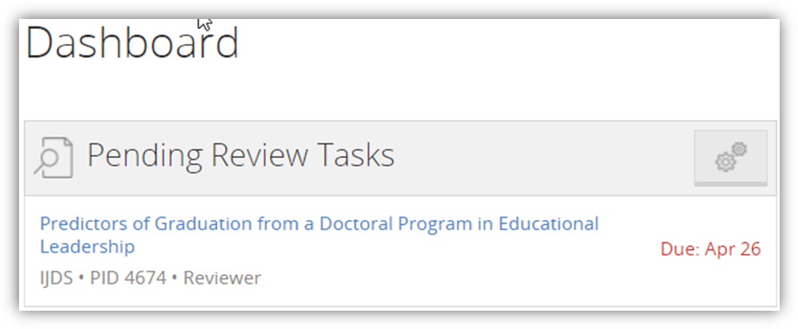
Figure 1. Click the paper's name to move to its review page
Once you are on the paper’s review page, click on Read Article to read the paper (Figure 2).
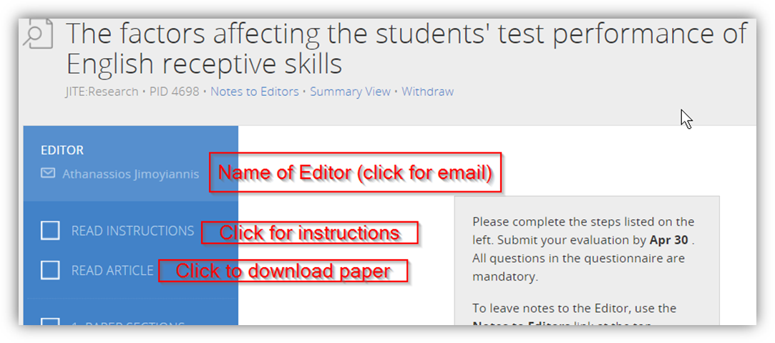
Figure 2. Click on Read Article to download a copy.
Your browser may open the paper in a browser window if you have it so configured
As you read the paper, compose your thoughts about its strengths, issues, and ways you can suggest for the author to improve the next draft. Then use the online evaluation form to provide your constructive comments, suggestions, and other feedback.
- Use Line Numbers in your review. We can accept feedback only via the online review form (not as files with track changes) so use the line numbers in your comments to point out where you see areas for improvement.
- Your role is to mentor, guide, and coach, not to referee. So, instead of just pointing out what is wrong, share your ideas on how to improve the paper as constructive criticism.
- Use constructive phrasing. Words can hurt, so take care how you phrase your suggestions to your colleagues. Instead of wording a critique as “You should,” word it as “The paper would be made stronger by.”
- Spend the time needed. To do a credible job, expect to spend two hours reading the paper and composing your ideas on how the authors can improve it. Engage fully with the submission – be thorough and comprehensive.
- Write your comments and suggestions for the author into a document. Later you will cut and paste your thoughts into the online evaluation form. The final part of the review is to indicate to the Editor your recommendations on the publication of this draft of the submission.
- Need more time? If you need a few extra days to complete your review, let the paper’s Editor know right away, either by email or by using the Note feature. The Editor will know to await your review.
- Reviewing as a non-expert. You may have been selected to review a paper precisely because the paper is outside your specialization. Our journals are read by colleagues from various fields and so, to ensure that papers are understandable by all readers, we need (and assign) non-specialists as reviewers. Indeed, if you as a non-expert have difficulties understanding what the paper is about, report that in your feedback as an area to be fixed. The Editor-in-Chief considers many criteria when assigning reviewers to papers.

OOPS! I WAS ASSIGNED A PAPER WHEN I AM UNAVAILABLE

While you can’t pick and choose which papers to review, you do choose when you will and won’t be assigned to review
Setting your availability. Nobody likes getting a review assignment while they are on holiday. To avoid this, let the system know when you expect to be unavailable to serve as on the Board as a reviewer. If for an extended period you will be unavailable to act as Reviewer, change your availability status in your ISI profile. (‘Sign On’ to your ISI account at http://My.InformingScience.org, click Profile and indicate in the Reviewing tab the period of your unavailability.) Letting the system know you are not available ensures that the EiC will not assign a paper to you during that time. During this period when you are not available to review, you will not be a member of the journal’s review board.
Setting the maximum number of reviews per year. You can also set in your Profile the maximum number of reviews you will do for the journal in a year. (Log in at http://My.InformingScience.org, click Profile, and click Reviewing Options to see these options (Figure 3).)
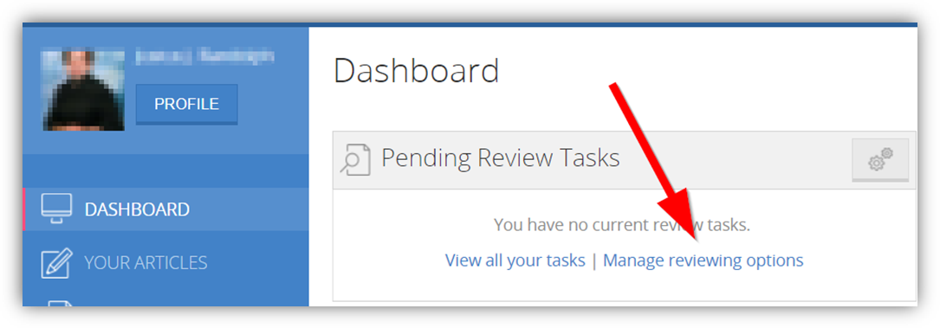
Figure 3. When you first log in at http://My.InformingScience.org, you will see the dashboard on your personal page. Here you can see all your editorial tasks and manage your reviewing options.
Set times when you will be unavailable to review and max reviews/yr
Withdrawing from reviewing a given paper. Of course, there are times when we unexpectedly become unavailable to review, such as during illness. If this happens, immediately click the Withdraw link shown in Figure 7. While you may withdraw from a review because of some unexpected life event, there is no picking and choosing which papers to review.

While you can’t pick and choose which papers to review, you do choose when you will and won’t be assigned to review
Setting your availability. Nobody likes getting a review assignment while they are on holiday. To avoid this, let the system know when you expect to be unavailable to serve as on the Board as a reviewer. If for an extended period you will be unavailable to act as Reviewer, change your availability status in your ISI profile. (‘Sign On’ to your ISI account at http://My.InformingScience.org, click Profile and indicate in the Reviewing tab the period of your unavailability.) Letting the system know you are not available ensures that the EiC will not assign a paper to you during that time. During this period when you are not available to review, you will not be a member of the journal’s review board.
Setting the maximum number of reviews per year. You can also set in your Profile the maximum number of reviews you will do for the journal in a year. (Log in at http://My.InformingScience.org, click Profile, and click Reviewing Options to see these options (Figure 3).)
Figure 4. When you first log in at http://My.InformingScience.org, you will see the dashboard on your personal page. Here you can see all your editorial tasks and manage your reviewing options.
Set times when you will be unavailable to review and max reviews/yr
Withdrawing from reviewing a given paper. Of course, there are times when we unexpectedly become unavailable to review, such as during illness. If this happens, immediately click the Withdraw link shown in Figure 7. While you may withdraw from a review because of some unexpected life event, there is no picking and choosing which papers to review.

ROLE 2: ENTERING YOUR SUGGESTIONS ONLINE USING THE ISI REVIEW SYSTEM

Step 1: Log in (using the link in your email or at http://My.InformingScience.org and, under Pending Review Tasks, click the name of the paper.
Clicking the paper’s title brings up its Paper Review page (Figures 4, 5, and 6).
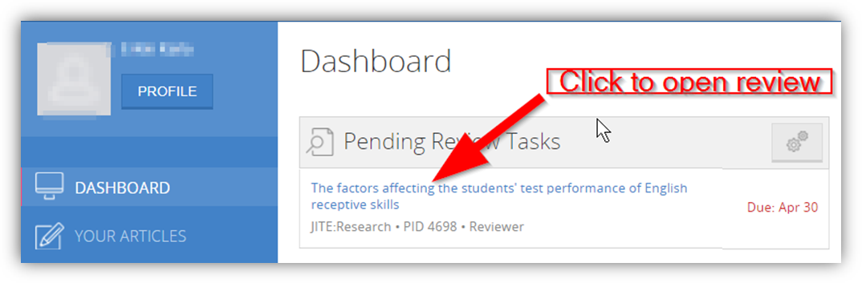
Figure 5. Log in (using the link in your email or at http://My.InformingScience.org)
and, under Pending Review Tasks, click the name of the paper.
Notification of a review assignment is stored online for your later review. You can see a copy of your assignment email by clicking on READ INSTRUCTIONS (see Figure 5).
To download the paper, click READ ARTICLE (see Figure 5). Below the paper’s title is its Paper ID (PID), a link to enter a Note for the Editor, and a link to Withdraw if unexpectedly you are unable to review (see Figure 6). Click on the Editor’s name to see her/his email address. If you need a few more days to review the paper, email the Editor.

Step 2. Enter your suggestions.
The paper review form in Figure 6 is for a paper that was assigned a three section evaluation form: 1. Paper Sections; 2. Your Overview; 3. Final Recommendations. Your paper’s evaluation form may be different. Click the link Summary View to see a copy of the items on your assignment’s evaluation form. Doing so may help you organize your thoughts before you enter them into the online form.
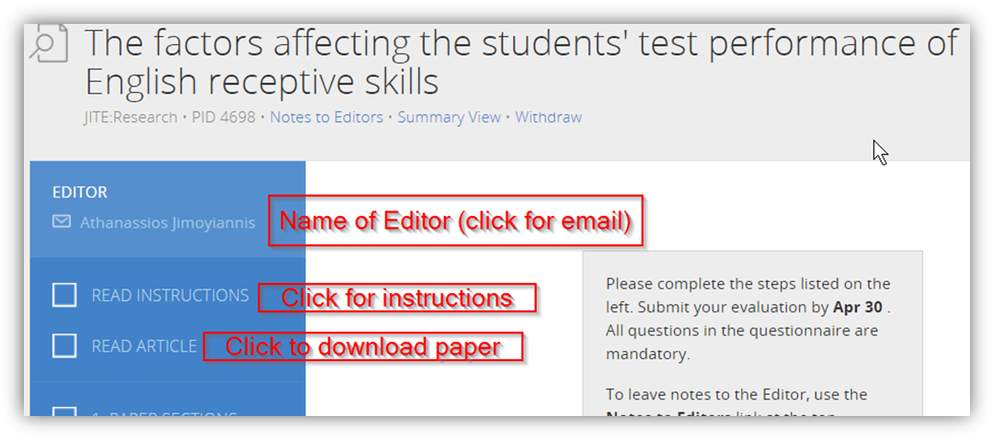
Figure 6.On the Paper's Review page, click the Editor’s name to show the editor’s email address.
Click Read Instructions to show the instructions

Your feedback to the Editor
Use the Notes feature. You can communicate with the paper’s Editor from the paper review site using the Note feature (see Figure 6). A copy of your note is stored with the paper and is available to the Editor and Editor-in-Chief.

Click Read Article to download the paper. To start your online review, click the sections below “Read Article.” In this example, you would click first on “1. Paper Sections”.
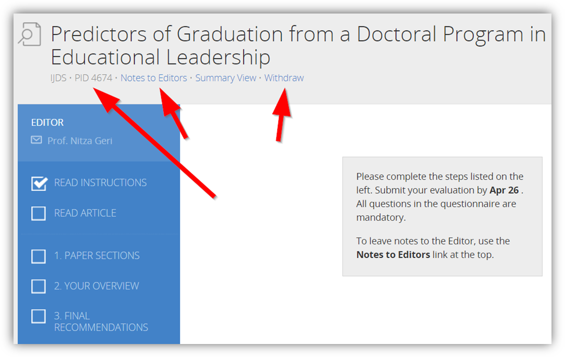
Figure 7. Other features include the Paper's ID, where to place notes for the Editor, how to bring up a Summary of the Evaluation Form, and in rare cases, how to withdraw from reviewing this paper.

Carrying Out a Review Step-by-Step
The paper you are assigned may have an evaluation form different from the three sectioned one shown above. Different evaluation forms are needed because there are many different kinds of academic papers. Different ISI journals accept different types of papers, including empirical research-based, qualitative research-based, mixed methods, case studies, theory-based, literature review or meta-study, policy reviews, concept papers, industry analysis, and likely other types as well. Each journal selects what types of papers it accepts and assigns it an evaluation form appropriate for that type of submission.
Some general issues apply to most types of submissions:
- Clarity. The wording needs to be understandable for all readers, not just for specialists. The wording, punctuation, and grammar need to be correct. Do not fix this for the author; instead, point out several of the line numbers of sentences that have problems.
- Development. The paper needs to move from one topic to the next in a logical way that is clear to understand.
- Novelty. Does the paper contribute to science? Does it bring forth anything new?
- Generalizability. If appropriate, are the findings or conclusions something that others might find useful?
- Format. All ISI journals use APA style formatting. You need not deal with minor problems, but if you see a major problem (such as the paper citing Abraham Lincoln as Abraham, L.), please do note this in your review.
- If you notice a similarity in the wording of the submission to that of other published works, please alert the paper’s Editor to look into possible plagiarism.
We recommend that you carry out your readings of the paper in three stages:
- Scan the paper’s verbiage and the figures. Would a reader get the gist of the paper by scanning the figures and the headings?
- Inspect for integration and coherence (development and flow) of the paper as a whole. Does the paper have paragraphs that spell out what it covers and have transition wording from one topic to the next?
- And finally, a detailed reading of each section of the paper to check for accuracy, currency (is it up to date), logic, as well as readability.
As you read the paper, jot down comments on issues that occur to you. When you later enter your thoughts into the online evaluation form, you then can use copy and paste to enter those thoughts into the form. Be sure to include positive comments about the paper’s good points.
Remember these points in composing your wording:
- Use constructive (not destructive) wording since you are writing for the author as a mentor.
- Maintain a balance (what is ‘right’ about the paper and what is ‘left’ to do to improve the paper; no submission is perfect, and none is without merit).
- Keep in mind that the journal’s readership crosses disciplines, so the paper must be clear. The purpose of the paper is to inform, not to impress. If you can’t understand the wording, other readers also will have problems, so in this case, the wording needs improvement. Let the author know what sections are unclear and, if you can, suggest better wording.

Be sure to save your review (if you are not yet finished) or clicking the Submit Evaluation button when you are done. (See the figure below.)

Examples of Constructively Worded Comments
Below are snippets that illustrate the mentoring, constructive wording we ask our reviewers to use to deliver the news that improvements are needed.
Introduction: This paper would be even stronger by adding a new section giving details on the environment that led to the research (economic, political, etc.). Without it, the reader is left to infer details and may infer incorrectly. For example, make it clear if the program was mandated, what funding was available, if and how technology was distributed to schools and students.
Literature Review: Adding a review of Change Theory literature here will provide a stronger basis for the subsequent Results and Findings.
Including more recent references will strengthen the literature review and demonstrate that the most recent developments have been taken into consideration. Examples of useful papers include [and list some examples of papers that should be read and, if appropriate, cited].
Method/Methodology: Consider rearranging the opening paragraph in this section so that lines 213 to 216 follow line 217. Doing this would improve flow. Have the paper provide further justification for the decision to use mixed methods; this will build a stronger case for accepting the results of the analysis. Explain to the reader what a mixed methods study does that a quantitative method only study does not. This justification might well fit as part of the Literature Review.

We Provide You with Feedback!
Your feedback to the author and Editor are key for the author to improve. But know that you too will receive feedback on your review to help you know what parts of your review were best received and how other reviewers have mentored the author.
The Editor provides you feedback on your review. After the paper’s Editor has read the submission and once the reviews are in from you and other reviewers, the Editor will provide each reviewer with brief remarks as feedback.
We send you a copy of the paper’s Decision Letter. The paper’s Editor uses your review and those of other reviewers to compose the paper’s Development Letter. The Decision Letter includes some generic (templated) verbiage plus the Development Letter. The Development Letter contains wording specific to improving this submission. For all submissions, regardless of whether the journal will continue toward publication, we send the corresponding author advice on how to improve this submission. You need to know this because we send you as one of the paper’s reviewers a copy of the letter we send the author. We send you a copy to help you better understand how this process works and your contribution to it Typically, you receive this email containing the decision letter 4-6 weeks after you complete your review.
Excellent Reviewers are offered promotion. From time to time, the Editor-in-Chief reviews the performance of all reviewers and offers promotions from Reviewer to Senior Reviewer and Associate Editor.
Reviewer Certificate for ISI Members. As one of the many benefits of being a paid member, ISI Members can have the system generate a Certificate certifying their service as a reviewer (Figure 7). If you are not yet a paid member of ISI, step up to Membership at http://Member.Informingscience.org
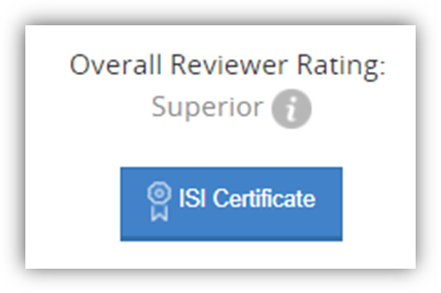
Figure 8. You can see your overall performance rating in your dashboard.
A benefit of ISI membership is that members can produce a reviewer certificate. If you are not yet a member, upgrade at http://Member.InformingScience.org
Your reviewing history. ISI values your professional service as a reviewer, and it is valuable to you and your academic career. You can access your reviewing history with ISI on your ISI Profile under “Your Reviews” (Figure 8).
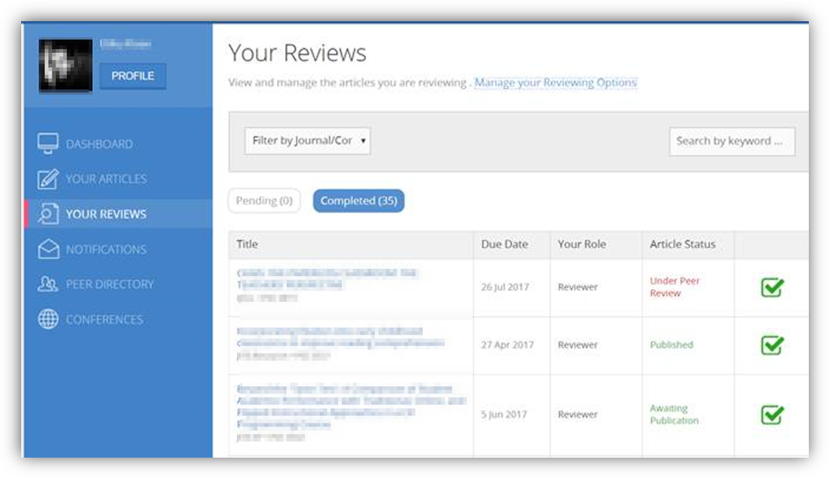
Figure 9. You can find your past and current reviews on the Your Review tab of your dashboard.
Click the paper’s title.

System won't let you submit your review?
The system checks to verify that you complete all the sections of a review. Suppose you get to the last tab of the review and the system won't let you submit your review. Check that you have completed all the sections. The system shows a check mark next to all completed sections. This is true even for the section that reads 1. INSTRUCTIONS. The system requires that you click "Next" on each section.

How to let the system know that you will be unavailable, limit the number of papers assigned, resign from the board, or volunteer to do more reviewing.
We know that your schedule may change. Here is how to adjust your Reviewing Options in your PROFILE to let the system (and the editors) know of these changes.
1) If you know that you will be unavailable for a period, uncheck the box next to Available and enter the dates when you will return. During this period going forward, you will not be assigned any additional papers.
2) You can select the maximum number of papers per journal per year that you will be assigned.
3) If you need a break between paper reviewing project, enter here the number of days.
4) If you will be unavailable for future reviewing, click the X to withdraw from the journal's review board.
5) To volunteer to review for additional journals, select the journal and click "Request".

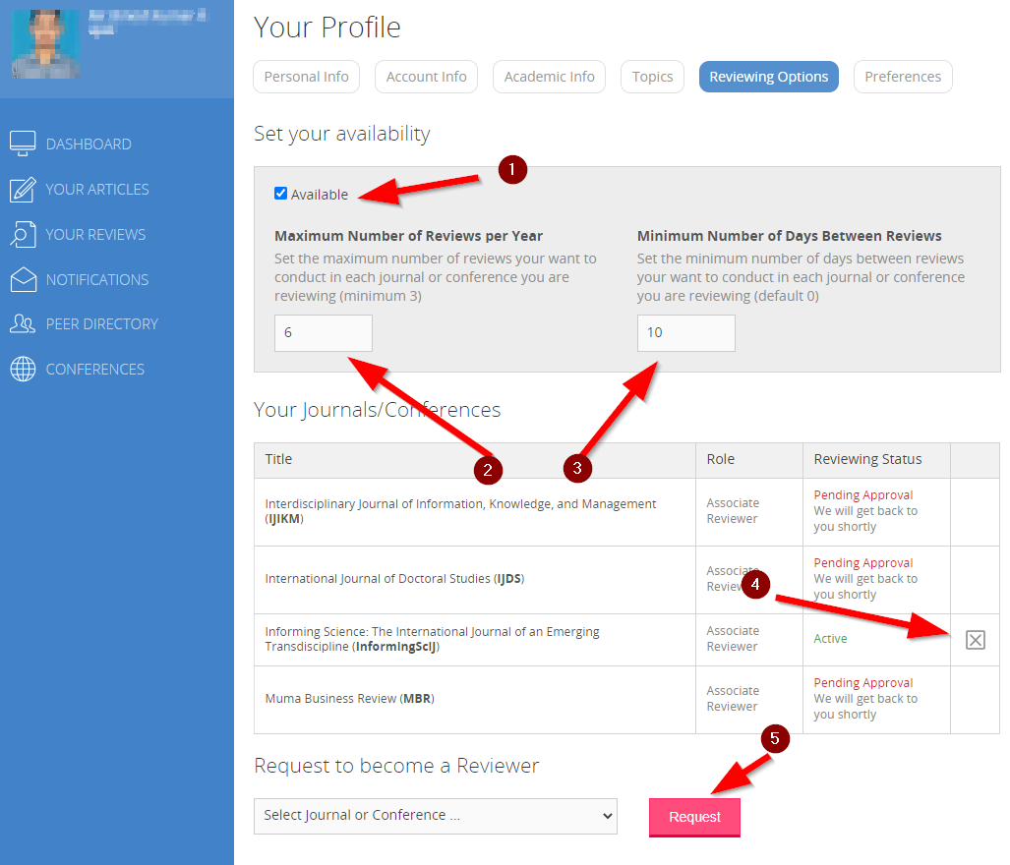

Thank you!
Thank you for your service to the academic community and for being a leader in improving the academic paper review process. Some journals focus on rejecting as many papers as they can, others on accepting almost all. Our journals’ mission is to help all authors to improve their craft as researchers. We do this by getting like-minded people together to mentor each other. As a reviewer, you are a leader, guide, and coach for authors. Thank you for your service.

