Editor-in-Chief-Manual

Table of contents
You are Part of the Solution, Fixing the Problems with Paper Reviewing 7
The ISI philosophy 7
Getting Started – The Essentials 7
Your role 7
An overview of your duties 8
Essentials of the Editor-in-Chief’s role in the review process 8
Scan 8
Prepare 9
Select the Editorial Board 9
Decide 9
Desk Reviewing 10
Scan a new submission for suitability 10
What to look for in your desk review 10
Generating a Similarity Report 10
Interpreting Similarity 13
Desk Decision 14
Rejecting a submission 14
Insert Template, Modify Wording, Save 15
Place submission on hold 15
Desk approving a submission and preparing it for review 16
Blind the submission 16
Add line numbers 17
Save a PDF of the blinded paper with line numbers 17
Select an Evaluation Form 17
Select the Editorial Board for this paper and set due dates 17
Select the editor 18
Assigning yourself as editor 19
Target dates 19
Select reviewers 20
Adding additional reviewers later 21
Removing Non-Performing Reviewers from you review board 21
Keep an eye on the review process 22
Decide: The decision process 26
Rate your editors’ performance 26
Accepting for publication 26
The Leadership Ladder: Adding, Promoting and Acknowledging People 27
Adding reviewers: A better way for determining the fit to review for your journal 27
Learn more about your reviewers 29
Promotion across levels (Associate to Senior) and between levels (Reviewer to Editor to Editor-in-Chief) 29
Reviewer Certificate for ISI Members. 29
Offering excellent reviewers a promotion 30
When should you promote people? 30
Promoting and mentoring reviewers and editors 30
Promoting Editor to AEiC 35
Promoting Reviewer to Editor 35
Give a pat on the back to excellent, experienced Reviewers and Editors 36
What about promoting yourself to senior editor-in-chief? 36
Acknowledging people 36
Fast-Tracking Papers from InSITE to your Journal 37
Common Issues 40
Making an A/EiC the paper’s editor 40
Assigning a different editor 40
Authors making extensive revisions that require a new review 41
Two useful system features: Activity Log and Notes (on this paper) 41
Changing the Due Date for a paper 41
Professional misconduct 42
Common Questions 43
How do I recommend an improvement to the system? 43
How often is the system upgraded? 43
How does an author get help with a review or submission? 43
How does a reviewer withdraw from an assigned paper? 43
How do I add a new editor to my board? 43
Why doesn’t the system display an editor or reviewer? 44
How can I email all reviewers and/or all editors? 44
An author emails me that the system will not let her/him upload the revision: what do I do? 44
What to do if your editor doesn’t respond? 44
A paper received only two good quality reviews: what do I do? 44
What if an author doesn’t want to revise a submitted paper? 44
What if an author does not submit a revised version after numerous reminders from the system? 45
What if an author disagrees with the revisions required and refuses to make any changes? 45
An author revises a paper that has been accepted but makes other substantial changes (e.g., to the analysis or model), can it be rejected? 45
What to do if you upload the wrong PDF? 45
After the author submitted a paper, the author wants to have a later version reviewed: what can I do? 45
Why are the raw reviewers’ comments not released to authors? 46
How does an author pay for a paper to be formatted? 46
How many A/EiCs should I have? 46
I received a request from a non-ISI conference chair to publish their papers: what should I do? 46
Can my journal run a Special Series? 46
What does the "Peer Review is not Active at this point for this article" error message mean? 46
How to Delete a YOUR NOTES item from your template 47
For Your Information 48
Author submission agreement 48
Changing your journal’s defaults 48
Overview of your menu tabs at http://My.InformingScience.org 49
Instructions for checking Editors to be listed in ToC 50
System Generated Emails 51
Notification to EiC that Editor has reviewed revised article 51
Reminder to Author to submit revised paper 51
Reminder to Reviewer to review assigned paper 51
Supporting Membership 52
Thank you 52

You are Part of the Solution, Fixing the Problems with Paper Reviewing

Thank you for your leadership as an A/Editor-in-Chief or EiC of a journal published by the Informing Science Institute

Our 5 "C"s
Following the APA style manual (American Psychological Association, 2020, p. 376-377), we seek to publish papers that do the following:
(a) contribute significantly to the content area covered by the journal,
(b) communicate with clarity and conciseness, and
(c) conform to the journal’s style guidelines.
You are part of the solution, publishing papers that communicate a clear and concise contribution that conforms to our style.

Our Rationale
Have you ever sent a paper you wrote to a journal, and didn’t hear about the review for the better part of a year or even longer? We have.
Have you ever received a decision letter that left you wondering how to proceed? Perhaps that decision letter contained contradictory or irrational guidance? We have.
We designed the paper review system for ISI journals to overcome these and other problems with the journal peer-review process. Instead of the old production model (reject defects), we at ISI journals use a continual process improvement model. While fewer than half of the papers submitted make it into print, we view our role as mentors to all authors, sharing with them our wisdom and the wisdom of our reviewers, to assist them to improve their submission. Most papers that we do publish undergo several rounds of revisions.
We also designed the system to avoid the problem of delayed reviewing of manuscripts. We endeavor to get back to authors with our initial assessment within two months of their submission. To do this, we have abandoned the model of asking Editors and Reviewers to accept assignments. We expect Editorial board members to accept their assignment.
You, as EiC, are vital to these improvements. They entail that you interact with authors, reviewers, and editors in new and better ways. This manual is to get us all on the same page, to inform you about the ISI philosophy of the paper review process, and to share with you how to use the ISI Paper Review automated system so you can to do your part.

The ISI philosophy
As an EiC for an ISI journal, your principal role is as a mentor to the editors, the authors, and the reviewers; that is, you are a key person in carrying out the mentoring that makes ISI one of the most constructive forces in higher education.
Your crucial role is that of an agent for improving research and researchers. While other journals ask only for gatekeepers, your role is as a guide. In ISI, we all help each other. Reviewers mentor authors, editors mentor reviewers and authors, and editors-in-chief mentor their editors.
This document is organized first to give you a quick view of your role and then to provide details on how to do the tasks of an EiC.
If you have questions about how to use the system not covered here, ask the Managing Editor.

Getting Started – The Essentials

Your role
In all journals, peer-reviewing aims to ensure the integrity and validity of research findings; all serious journals use a rigorous process to determine this. The submission review process is the main tool we have to ensure that new scientific knowledge published is honest, accurate, ethical, and valuable. In effect, it acts as a measure of quality assurance and ‘certifies’ the new knowledge.
The journals of the ISI go a step beyond this. We are a mentoring organization and so request our Editors-in-Chief to assist reviewers and editors by being coaches and guides to the authors, reviewers, and editors. We use the paper review process to support authors by providing them with mentoring suggestions on ways to improve their work. We do this by packaging constructive and informed feedback using best practices methods gleaned from the literature. For example, our suggestions are do-able and concrete. We treat authors with respect.
All ISI journals need to follow ISI’s policy regarding the paper review process. ISI’s policy is that rejections for issues like lack of novelty should occur at the desk review stage. Once a paper has been reviewed, it can still be rejected for lack of novelty or any other issue.
But we agree to take seriously our choice to accept pending revision. If, after reviewing the editor’s comments, the Editor and the EiC choose to accept the paper for publication pending revision, the journal’s editorial staff agrees to work with the author to make the paper publishable. This is our contract with the author. If a paper will require substantial revision, select REJECT. If you feel the rejected paper has value and should be revised, select the template to encourage the author to resubmit after revision as a new paper. Not all papers accepted pending revision are published. The author may indicate to the system “No Intention to Revise,” and there have been rare cases where the author is unresponsive or unwilling to make the changes noted in the development letter.
Another unique feature of our journals is that we provide the authors with developmental suggestions that point out those do-able improvements needed for the paper to become publishable. We provide these suggestions even for papers we reject. This is part of our mission.
Most commonly, we can work with the author to make the accepted paper fully publishable over a few rounds of revision. Our goal is to provide the author with a development letter that is clear and so as minimize the number of rounds of revision necessary. Typically, the papers we publish require several rounds of revision.
As Editor-in-Chief, you play the central role in managing the review process with the help of your editors and reviewers. The editor assigned to a paper uses the assigned reviewers’ comments and suggestions to synthesize and compose wording designed to guide the author on ways to improve the submission. Your task is to monitor the review process and make the final decision whether or not to progress a submission towards publication. Your task also includes reviewing the performance of and mentoring A/Editors while also ensuring the journal adheres to ISI’s mission in all respects.

An overview of your duties
In your role as an ISI journal Editor-in-Chief, you have four primary responsibilities:
- Scan new submissions for suitability (desk review)
- Prepare the submission for review
- Select the editorial board (editor and reviewers)
- Decide (accept with more revisions, accept for publication as is)

This document has many answers to questions that you will encounter. We list at the end frequently asked questions. When you have other questions about how to use the system, contact the Managing Editor. If you have other questions or concerns about editorial policies, contact the Executive Director. Refer to https://www.informingscience.org/Community/ISITeam to see the current Executive Director.

Note: You can find a link to this EiC Manual in your system dashboard, near the top, by clicking on Help, then the tab FOR EDITORS-IN-CHIEF. If you are serving as the Editor of a paper, be sure to read and follow the instructions found in the Editors’ Manual found in your system’s help as FOR EDITORS.

Essentials of the Editor-in-Chief’s role in the review process
Let’s first go over how this process works in brief, from start to finish.

Scan
Once the system notifies of a paper’s submission, download and read it. Determine if the submission is relevant and of suitable quality for the journal, and so has a good possibility of acceptance following review and revisions.

Prepare
If you will be desk approving the paper for external review, prepare it, and upload a blinded PDF. That is, save the paper, blind it (remove any identification of author or affiliation in the paper or its properties), add line numbers, and upload the blinded PDF file with line and page numbers to the system.

Select the Editorial Board
Select an editor from those listed in the system as being available and, if possible, not currently handling another paper. Select the “Assign Editor” template from the “Your Notepad” menu, insert the wording into the comments box, and, as necessary, change any wording.
The system will recommend target dates for the editor and the reviewers. (You can change these recommendations in your control panel – see Figure 44.) These target dates are used by the system to know when to send reminders. We suggest that you leave the target date for reviewers at 14 days in the future to allow time for the system to send a few “review is past due” reminders. And we recommend leaving the target date for editors as 21-28 days in the future for the same reason.
Then select the maximum number of reviewers. The system will prevent you from assigning additional reviewers once you have assigned this number. Select reviewers from those listed in the system as being available and not currently reviewing another paper. The system initially lists the reviewers for selection in order of topic fit. As the paper should be readable and understood by academics outside the field, we recommend that you also select a few reviewers having a 20-40% match. Select both those with a good record and those without a good record.
Important note: Editors should not also be a reviewer (but for exceptional cases).

Decide
At this point, the editor takes over the review process, and you monitor all your papers. (The system will email you a progress report and exception reports if there are problems, all of which you can see from your dashboard at http://My.InformingScience.org.)
When the reviews have been submitted, the editor makes a recommendation to you regarding acceptance and prepares for you a draft Decision Letter to send to the author that includes a ‘Development Letter’ within it. The decision letter consists of boilerplate wording from the templates plus wording specific for this paper. The boilerplate templates provide best practices wording for rejecting, accepting pending revision and formatting, or (once a paper has been reviewed and formatted as camera-ready) accepting it for publication.
When the editor makes this recommendation (rejects, accepts the paper subject to revision, or accepts a paper for publication), the system emails you for you to review this recommendation and the wording the editor inserted. At this point, the system has NOT contacted the author.
At this point, you decide. You review the editor’s recommendation and decision letter and either approve the letter as editor composed it, or you modify the decision and/or letter as part of your mentoring of editors. The decisions and letters that your editors write require a review by you as the EiC or one of your A/EiCs. Only then does the system notify the author. Keep in mind that, since the system will not notify the author until you act, the system continues to send reminders to the editor and the EiC or A/EiC until you act on the editor’s recommendation.
It is extremely important that as EiC or A/EiC, you review the decision letters that Editors write to verify that they use the Best Practices templates and paste (or insert a link) mentoring development suggestions. The Informing Science Institute requires this quality assurance step to ensure that all our communications with authors are written in a form and format to help them become better at their profession. (See target dates for reviewers and the editor.)
Do not accept a paper as final until the paper is in a camera-ready format (or close to it). It needs to include all author information (bios and photos). You and your editor should read each sentence of papers accepted for publication to verify that it is up to the quality we all expect.

For Your Information. Before you even see the paper, a lot occurs behind the scenes. That is, before the author can submit the paper, the system requires a few things to happen.
First, the corresponding author needs to have an account. Then the author fills in information about the paper, including its abstract, and uploads the file.
Second, the corresponding author needs also to indicate any co-authors. All co-authors need to have or to obtain an Informing Science Institute account at http://Join.InformingScience.org. If a co-author is not already in the system when the paper is submitted, the system creates a free ISI colleague account for that person and requires verification from the co-author that the email address is correct, the individual is a co-author, and has not and will not submit the paper to another outlet. This is necessary for two reasons: (i) we need co-authors to understand that the paper is under review so that they do not submit the paper to a different outlet; and (ii) occasionally, a new researcher will add others as co-authors those who do not accept co-authorship. The corresponding author can complete the submission of the paper only after all co-authors agree to it. The system handles all these details.
Third, the corresponding author selects topics by which the system can match reviewers to the paper’s topics.
The last step is to complete submission by the author agreeing to the terms for submission
The following sections describe each of these steps is in detail.

Desk Reviewing
When the corresponding author submits a paper to your journal, the system emails you a notification of the new submission. The system also shows this new submission (and all submissions still under review) on your page at http://My.Informingscience.org, and in the weekly email updates that it sends to you about your journal’s submissions. The following sections explain in detail the steps for detailing with new submissions.

Scan a new submission for suitability
Once you receive notification that a new submission, download it, read it, and determine if the submission is relevant and of suitable quality for the journal, and so has a good possibility of acceptance following review and revisions. Don’t send a paper needing substantial work out for review.

What to look for in your desk review
Read and review the submission for suitability and possibility of acceptance following revisions, using these criteria:
- Relevance. Is it relevant to your journal?
- Usefulness and generalizability. Will it be useful to your readership? Are the results generalizable, or is it just a report that applies to only one institution?
- Novelty. Does it make a novel contribution to knowledge, or is it a ‘me too’ paper?
- Good science. Is it methodologically sound? Does it include a robust literature review?
- Clarity and conciseness. Our journals are transdisciplinary, so all the readers of your journal should be able to understand and benefit from this potential contribution.

Generating a Similarity Report
If Admin has enabled similarity checking for your journal, you will be able to request a report on new submissions using iThenticate.
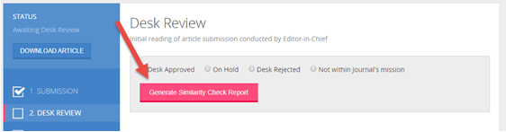
It may take up to 1 minute for the paper to be analyzed.
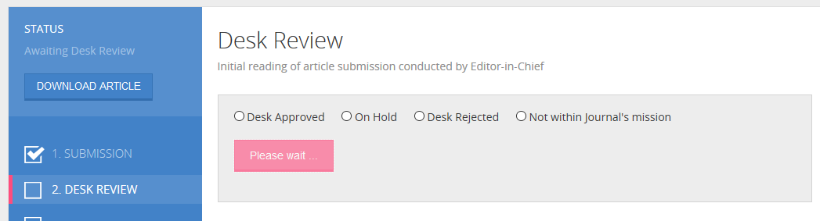
When it is generated, you can view the report by clicking the link View Similarity Report.
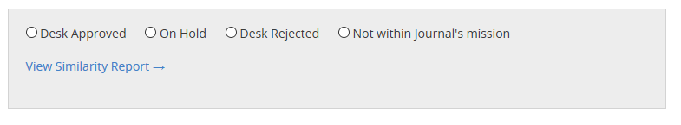

Save the Similarity Report URL in the paper's notes
Do not regenerate similarity reports, but rather save the URL in the paper's notes. Each similarity check wastes time and wastes money. (It costs us over 75 cents USD per report.)

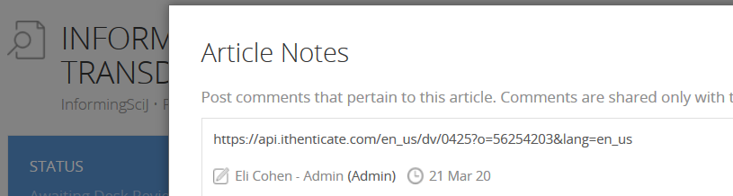

To avoid seeing false high similarity percentages, the default filtering is set so as not to check quoted materials or references and to list similarities only for large amounts of text. If you wish, you can click the filter to change these settings. Click the Filter to include them in the report. Read more about how to read the report at https://www.aje.com/arc/guide-how-to-read-ithenticate-report/ or watch the video at https://vimeo.com/210865038 . All papers will have some similarity to other papers, so be sure to add filters so as not be be distracted with small similarities to common wording, such as mention of "the Ideal Mentor Scale" and "Self-Efficacy".
If you see a large similarity with another work, check the source of the similarity to determine if it is the author’s thesis or dissertation. The APA and we encourage authors to use journals as a broader outlet to disseminate dissertation research. If you feel the content is appropriate for review and that it has been adapted to the mission of your journals, we hope that you will advance the paper for review. We do not consider such works as plagiarized.

If you suspect plagiarism, place the paper on HOLD (see below) and ask the Executive Director (executivedirector@informingscience.org) to investigate.
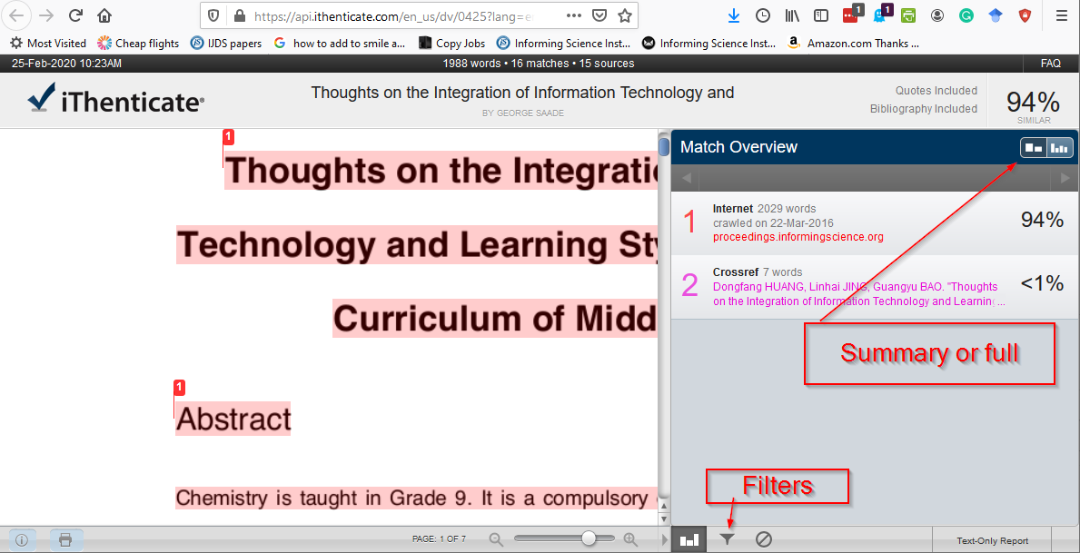
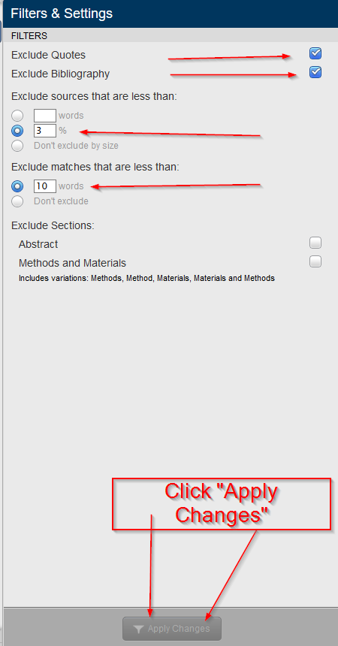

Interpreting Similarity
What is the "Magic Number"? There isn't one. At this point, you downloaded and read the paper. You determine that it might be publishable in your journal following revision. But before you fully advance it for external review, check to make sure that its wording has not been previously published by this author inappropriately (self-plagiarism) or by another author (plagiarism). If you do find a high level of similarity with just one source, see if that source was the author's dissertation or such. It is good practice to submit portions of one's dissertation or otherwise unpublished works to journals. So, focus on what is similar rather than a number. There may be instances where the author has used a quote and referenced the material appropriately or has used words from their own paper that has been published previously and been cited appropriately.

Interpreting the plagiarism checker requires a bit of deftness. You cannot simply look at the percentage of material found in other sources. Until you change the filter, for example, iThenticate will list items in the bibliography as well as ones found in other documents. And common phrases and even phrases in quotes may be included in that percentage of material found in other sources. If much of the material is taken from just one or two other sources, you should be alarmed. The point is, don’t rely on a single number. Focus on what was and was not found in other sources.
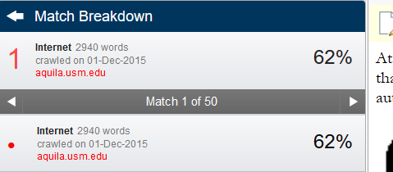
Figure 1. Interpreting plagiarism checkers requires discretion
It turns out that this paper was the author's dissertation. When this source was excluded, the similarity was 0%.
If you suspect plagiarism, place the submission On Hold and provide complete information about why you suspect plagiarism to the Executive Director. The Executive Director will investigate and report the results to the Board of Governors if warranted. We take plagiarism seriously. See Professional Misconduct.

Desk Decision
Depending on the above, select one of the available options:
- Desk approved.
- Place the paper on HOLD while the author addresses your concerns.
- Desk reject due to major deficiencies or for poor English.
- Desk reject because the paper does not fit the journal; that is, it is not within the journal’s mission.
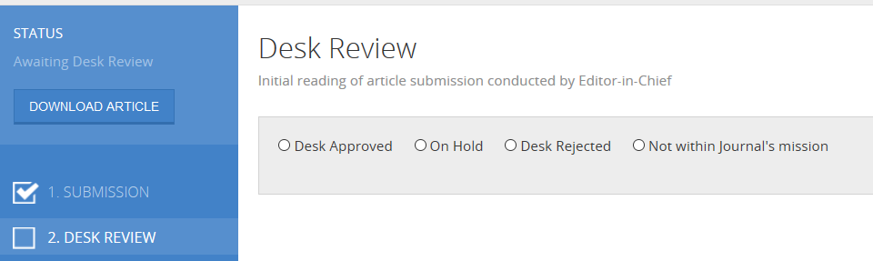
Figure 2. Desk review options

Rejecting a submission
If you are rejecting the paper for any reason, the system will email the author with your decision along with your comments. In Your Notepad, there are Best Practices templates to get you started for the three most common reasons for desk rejecting a paper in Step 1: (i) the paper has major deficiencies; (ii) its topic falls outside the mission of the journal; or (iii) its use of International English would create problems for readers of the journals.
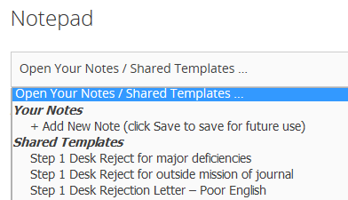
Figure 3. Best Practice templates for desk rejection
Select the appropriate Best Practices template and Insert it into your dialogue box. Once the template’s wording is in the Comments for Author field, modify it as needed. The system will fill in for you the placeholders; for example, [ARTICLE-ID], [ARTICLE-TITLE]. When you click the PREVIEW button, you see the message formatted with the placeholders filled in. Just remember to click SUBMIT.
To reject the paper for “Poor English,” the template offers the author the opportunity to resubmit the paper following professional copy-editing. After you insert the wording from the template, you may wish to remove this wording.

Insert Template, Modify Wording, Save
The templates provided are revised from time to time to provide the wording for its journals most consistent with the mission of the Informing Science Institute. We ask you to Insert the wording from Your Notepad and then modify it as necessary before clicking SUBMIT.
For example, if the wording in the template reads "EiC" and you want the wording to read "A/EiC", after inserting the template, change the wording before clicking SUBMIT or SAVE.

Place submission on hold
If you feel the paper has merit but needs some improvements before you can send it out for peer review, you can select the “On Hold” decision. Placing a paper on hold allows you to communicate with the author to ask for revisions before passing the revised paper for external review. Your focus at this point is on content, not form. That is, don’t worry about APA citation standards, but rather focus on the readability of the paper and whether the material is presented logically and makes sense.
There is a template for placing a submission on hold. Insert the template into the Comments for Author box from Your Notepad and adapt it as you wish. If you have comments in a file, upload those to the system using the Upload & Insert File feature and add the link to your uploaded file into the templated wording.
There are two additional things you need to do. One is to check the box “Remove Submitted Doc file to allow the author to resubmit,” and the second is to enter a target date for the author to get back to you. The system uses this date to send reminders to the author and you. You can change this target date later. The reminders are really helpful to remind busy authors of their paper. If the author of a paper on hold doesn’t respond or elects not to revise the paper, revisit the Desk Review page and reject the paper.
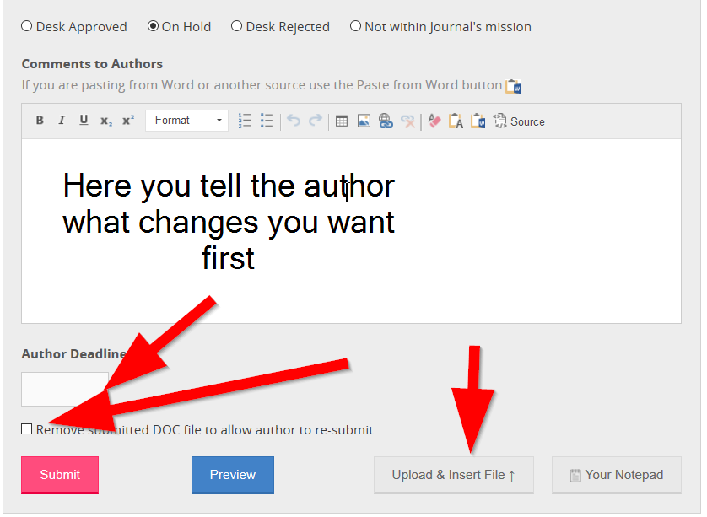
Figure 4. Placing a paper on hold requires writing the author, setting a target date, and removing the old file.
In the Comments to Authors box, you insert a template from Your Notepad and then modify it as needed.

Desk approving a submission and preparing it for review
If the paper reads well and is likely to be publishable in your journal following revision, advance it for peer review. Here is how. If you will be desk approving it for external review, prepare the paper for review and upload a blinded PDF. That is, you will save the paper, blind it (remove any identification of author or affiliation in the paper or its properties), add line numbers, and upload the blinded PDF with line and page numbers to the system. Each of the steps is now explained.

Blind the submission
Before you send the paper out for review, you need to “blind” the paper; that is, ensure that the paper does not identify the authors or their institution in the text or the references. Check not just the text but also the headers and footers. In Word, also inspect the document to remove document properties and other personalized meta-data (Figure 5). You do this through the File/Info/Check for Issues menu or File/Check for Issues/Inspect Document menu. Unless the headers have author information in them, you can leave the headers and footers.
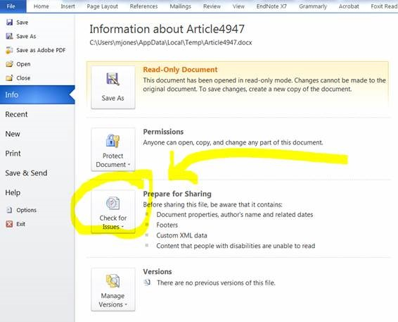
Figure 5. Remove document properties and meta-data

Add line numbers
In Word, you add line numbers from the Layout tab (Figure 6).
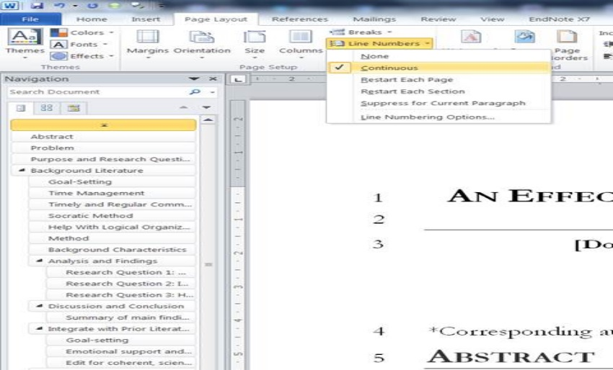
Figure 6
. Adding line numbers
Be sure to click Ctrl-A to select the entire document before you add line numbers. Otherwise, Word will add line numbers only to the current section, not the entire document. After you add line numbers, verify that the entire document has line numbers.

Save a PDF of the blinded paper with line numbers
Save the one complete file as a PDF and upload it to the system. For large files, the file size can be reduced by lowering the resolution of images. Use Word to save the images in a lower resolution (see https://support.office.com/en-us/article/reduce-the-file-size-of-a-picture-in-microsoft-office-8db7211c-d958-457c-babd-194109eb9535) then make a PDF from this file. Or you can use an online PDF compressor, such as https://www.ilovepdf.com/compress_pdf. Remove spaces and any special characters such as “&” and “<” in filenames of documents uploaded. These characters may result in an invalid URL.

Select an Evaluation Form
Select the Evaluation Form from the drop-down menu (usually the default form). Note that the form can be checked by clicking on Preview to the right of the menu. Click the Save button.

Keep in mind that you can create new Evaluation Forms and are not limited to those already in your drop-down menu. Ask the Managing Editor for help with creating or modifying evaluation forms.

Select the Editorial Board for this paper and set due dates
Now that you have a paper that you want to go out for review, the next step is to select an editor, assign due dates, and select reviewers (and, if necessary, change the maximum number of reviewers).

Select the editor
Click on the Editorial Board menu on the left-hand side and then the Editor button on the right.

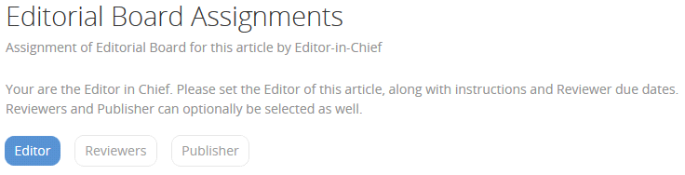
Figure 7. Select the editor
The system lists available editors by order of topic match. The system also provides additional statistics about an editor, including the following:
- date when appointed as editor
- papers assigned in total, and papers assigned in the last 12 months for your journal
- papers completed in total, and papers completed in the last 12 months
- number of non-responses to an assignment
- number of papers pending
- their reviewer rating (this rating is the average of all editors’ ratings for all journals for this person as a reviewer)
- their editor rating (this is what you and other EiCs have indicated)
These statistics are useful to consider when making your appointment decision. For example, an editor may have a high topic match but has several papers pending; that is, the number they are currently working on. Avoid overloading editors. Another consideration is the number of non-responses from the editor. Perhaps the editor needs more mentoring through the review process, or perhaps the editor needs more supervision or training.
Now that you have decided on the editor to appoint for this paper select the “Step 2 Assign Editor” template from Your Notepad drop-down menu (Figure 8) and Insert it into the comment field. Once you have inserted the wording from the template, you can modify it if need be. But typically, you need not make any modifications. The system will insert the editor’s name and such into the template, but you can check the letter by clicking on the Preview button.
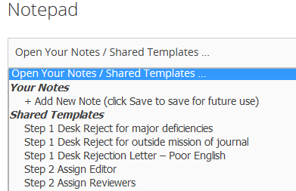
Figure 8. Best Practice templates for assigning Editor and Reviewers

The system does a lot of the busy work for you. The template letter identifies you; that is, the EiC or AEiC who assigned the new submission. Its wording makes it easy for the editors to remember what they are to do since it contains important guidance. The editor’s assignment email includes a direct link to the assigned paper and reminds editors that they can find the authors’ names and email addresses on their personal dashboard.

Assigning yourself as editor
Do you want to assign yourself as the editor for a new paper. It is simple. In Step 3. Editorial Board, don't select any editor.
If you previously assigned an editor and now need to take over, just click the "reset" link next to the Assign Editor (near the top of the page) and then at the bottom of the page click Set Editor. Then you will serve as the paper's new editor.

Target dates
The system inserts default due dates for reviewers at two weeks after assignment and for the editor at four weeks after assignment (Figure 9). These target dates were selected on purpose. We endeavor to provide prompt feedback to authors. Giving a longer review window does not generate better reviews, only delayed ones. Some reviewers will review their assignment within a days of assignment or after the first reminder. Others will wait until their target due date is approaching or is past. For this reason, we ask editors to look over the paper two weeks after the initial target dates for reviewers. If a reviewer asks for an extended date more than two weeks after the initial date, the editor can wait, but typically reviewers who will provide a review do so within two weeks after the initial reviewer due date.
The target dates can be extended, but be aware that they are used to keep the schedule from slipping too much.
The system uses these target due dates to schedule sending out reminders. If you change when items are due, be sure to change the date in the system.
The system also inserts the default maximum reviewers that you are allowed to assign at 6 (Figure 9), but you can change that default number.
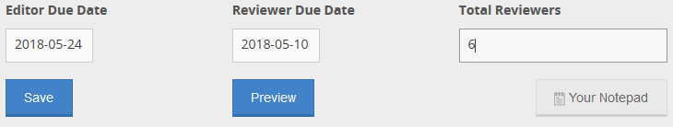
Figure 9. Setting editor and reviewer due dates and number of reviewers
Click on the red SET EDITOR button at the bottom of the web page. Within a few hours, the system will email your letter to the editor who chairs the ad hoc paper review committee (the committee includes the editor and the paper’s reviewers). The system uses the due dates for the editor and the reviewers to send reminders.

Select reviewers
Next, select the reviewers. While still on the Editorial Board menu, click on the Reviewers tab button (Figure 10) to select the reviewers and create a letter for them.
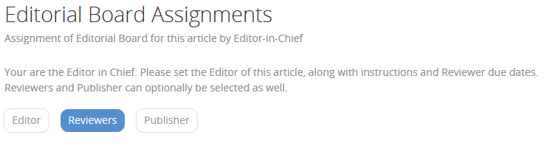
Figure 10. Select the reviewers
As before, the system initially lists available reviewers by order of topic match with the paper’s topics and provides you with statistics about the reviewers. As mentioned above, the default maximum number of reviewers in this example was set at 6, but you can change that to fewer or more for each paper, or you can even change the defaults.
To obtain at least three good quality reviewers within a few weeks, we recommend that you appoint 6-8 reviewers using the following criteria:
- The number in the field “In last 12 months for this Journal” should be fewer than 5.
- “Pending” should be 0.
- Select a mix of responsive vs. non-responsive reviewers and a variety of ratings. We suggest that you include a few of the non-responsive reviewers to help you determine whether or not to retire them from your review board as non-performing members. The goal is to keep and promote productive reviewers and prune names from your review board those whose listing diminishes your journal’s reputation.
When you have clicked on the reviewers you want to appoint, select the “Step 2 Assign Reviewers” template from Your Notepad drop-down menu (Figure 8). You can check the letter by clicking on the Preview button. Avoid unhappy editors: do not list or assign any editor as a reviewer.
At this point, the editor you selected takes over, so typically this paper is out of your hands for about two months while the reviewers enter their reviews, and the editor creates the Decision Letter. The system sends reminders to the reviewers and the editor periodically based on the target dates you set for reminders.

A note about target dates for reviewers and the editor. ISI’s journals endeavor to do things better than most other journals by providing authors with prompt feedback; that is, within a few months. We are mindful that giving reviewers and editors more time does not improve the quality of the work. Typically, you would use the default target date in the system for reviewers to complete their review, which is two weeks hence. We set a short target date on purpose. We don’t expect all reviewers to complete their review by this target date. We suggest that you leave the target date for reviewers at 14 days to allow time for the system to send a few “review is past due” reminders.
We understand human nature is that some reviews will come in late; many of us find time for a task only after it is past due. You would also use the default target date in the system for editors, which is four weeks hence.
We recommend that editors start working on the development letter a couple of weeks after the reviewers’ target date. So, we recommend leaving the target date for editors as 21-28 days hence to allow the system to send a few reminders. This scheduling provides time for late reviews to arrive. If a reviewer asks for an extension, change the due date in the system (see changing the due date) and notify the editor. If the editor asks for an extension, also change the Editor due date in the system.

Adding additional reviewers later
In some cases, even though you initially assign a reasonable number of reviewer to a submission, you do not receive a suitable number of quality reviews. In that case, things get tricky.
1. Remove consistently non-performing reviewers from your board.
2. Change the paper's maximum number of reviewers to a higher number to allow additional reviewers.
3. Change the reviewer and editor DUE DATE to give the reviewers at least 2 weeks to review and editors 2 weeks after the new reviewer due date.
4. Change the letter to the reviewers, if necessary. The new wording might mention that you are adding them late because they are great reviewers.
5. Assign new reviewers.
6. Click SUBMIT.

Removing Non-Performing Reviewers from you review board
Sometimes reviewers consistent do not respond or respond without mentoring feedback. Since you cannot rely on these colleagues, it is time to remove them from your review board.
Check the non-performing reviewers' ratings. If they are consistently poor performances, send them a letter like the one below and remove them from your review board by clicking the "x" near their names on the REVIEWER tab of your dashboard.
** This is a sample replace underlined words to fit your situation**
Ismail Last Name
University Name (Indonesia)
Ismail,
Thank you for your prior service as a member of the International Board of Reviewers of Informing Science: the International Journal of an Emerging Transdiscipline. To make room for other reviewers, we are relieving you of your duties and obligations as a reviewer to the journal. This means that your name has been removed from the Board of Reviewers and you will not be assigned new papers to mentor.
The journal is published by the Informing Science Institute (ISI). Serving as a reviewer for an ISI journal requires an exceptionally high level of commitment, and we understand that not everyone can do this throughout their career and throughout the year. The role of the ISI reviewer is more like a coach than an umpire. Our submission evaluations process requires reviewers to provide mentoring feedback promptly for the paper’s author and editor. Other journals require just serving as a specialist, scanning papers to spot mistakes. ISI journals call on reviewers to provide authors with constructive feedback in a form that helps them improve their submission. More to the point, while the goal of some journals is to find reasons to reject a submission, our goal is to help authors improve their submissions. All this requires an exceptionally high level of professional commitment from reviewers. You can find details on how to use our updated paper review system and our expectations in the Reviewers' Manual.
Should you find yourself in a situation where you can resume your prior commitment to serve as a mentoring reviewer, please again volunteer again online at http://My.InformingScience.org. When you do, take care to be complete when selecting topics of interest and expertise. We rely on these topics to match papers with reviewers, and now we look carefully at the topics you select and your updated list of publications to ensure a match with the journal’s needs when selecting which reviewer volunteers to add to the international review board. If you select too few topics on which you will review, we will be unable to accept your application.
When you do volunteer, you will find new options available to you, such as specifying the maximum number of papers you will review each year and the ability to indicate periods when you will be unavailable to review. You will also find that we acknowledge excellence in reviewing through reviewer badges of excellence and through Best Reviewer awards given monthly. This is outlined in the Reviewers' Manual.
Thank you again for your prior service,

-eli
Dr. Eli Cohen, Executive Director
EliCohen@InformingScience.org
on behalf of the Board of Governors, Informing Science Institute
and the Editors-in-Chief of ISI journals

Keep an eye on the review process
Log in several times a week to check your dashboard for delays (Figure 11 and Figure 12). The system will email you weekly reports on the progress. You can check the current status in order of urgency at https://www.informingscience.org/Member/Reviews?PublicationEntityID=0&Status=4&OrderBy=Urgency. Two types of papers require your immediate attention:
- The editor made a decision and entered a decision letter that awaits your approval. The system marks these as Awaiting EiC Decision. You need to either approve or change the decision and the letter to the author.
- The editor is late in making a decision; that is, the Due Date has passed. If you forget to set the Editor’s Due Date, the system uses the Reviewers’ Due Date.
You may need to remind editors to do their job of rating reviewers and of creating a suitable development letter. In the worst-case scenario, you may need to follow up with an editor with a private email and even take over for a non-performing editor.
The system also lists Submissions on Hold.
We expect some reviews to be late since some reviewers wait until they receive one or two past due reminders before finishing (or even starting) their reviews. We set the reviewer due date early for this reason and ask the Editor not to look at reviews until two weeks after the review due date. That is when we set the Editor’s due date. The system sends reminders to reviewers and editors automatically (a week before, a day before, two days late, a week after the target date, and a week after that). Editors do not receive a copy of such system reminders to reviewers.
For papers that are very late because of a non-responsive editor, the EiC or A/EiC needs to serve as editor for that paper. We have learned in the past that assigning a late paper to a new editor creates worse problems with delays and miscommunications. If you do assign a paper to a new editor, be sure to update the editor's due date for a few weeks hence. You will also need to manually change the editor’s name in the “Assign Editor” template. Do take care to assign it to a productive editor, not a problem editor. Preferably, just take over the paper by clicking Reset and then at the bottom of the screen, click SET EDITOR and Submit (Figure 13). The designated A/EiC and Editor fields for the paper are then blank. You may also need to change the Editor Due Date (and then click Save).
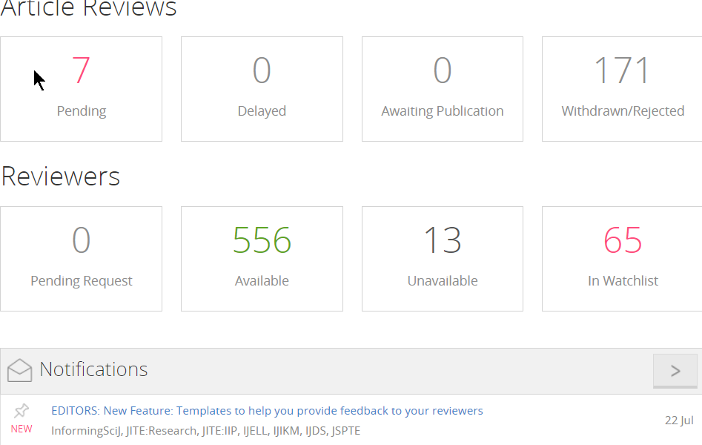
Figure 11. EiC dashboard shows the progress of papers

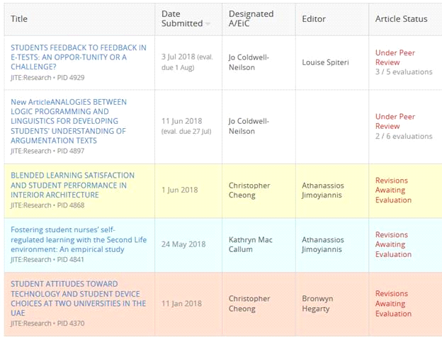
Figure 12. The Article Reviews tab shows the progress of all papers. Those behind schedule are color-coded.

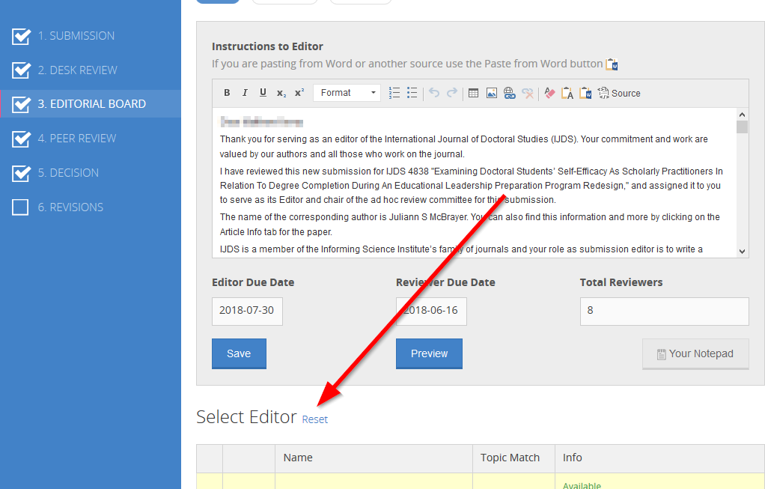
Figure 13. Reset the Editor when EiC takes over from a non-performing editor
When there are multiple EiCs and AEiCs available for assignment to a paper, the Article Reviews tab shows which A/EiC was designated for each paper as well as who is the Editor. This gives you a better understanding of who has been assigned what (as well as which papers are behind their target dates.) A copy of all correspondence outside of the system should be copied into the paper’s Notes (see Notes Feature and Activity Log).
If necessary, you can change the designated EiC on the Editorial Board page (Figure 14).
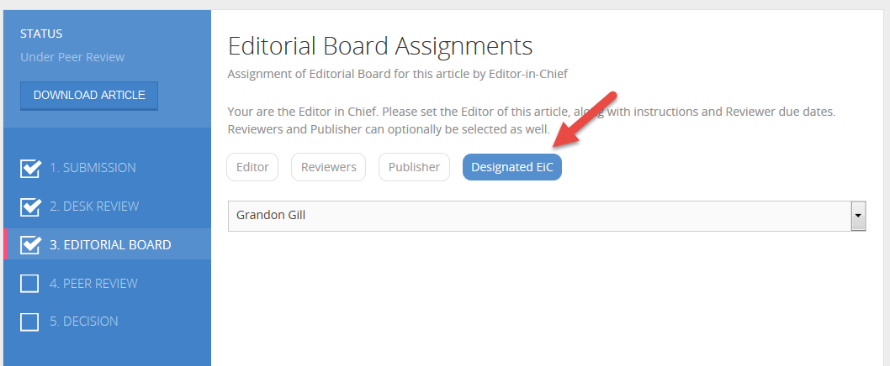
Figure 14. Changing the designated EiC
And to keep you on track, you can now see not only what papers are coming due, but also which ones are past due by clicking on Calendar View on the Article Reviews page (Figure 15).
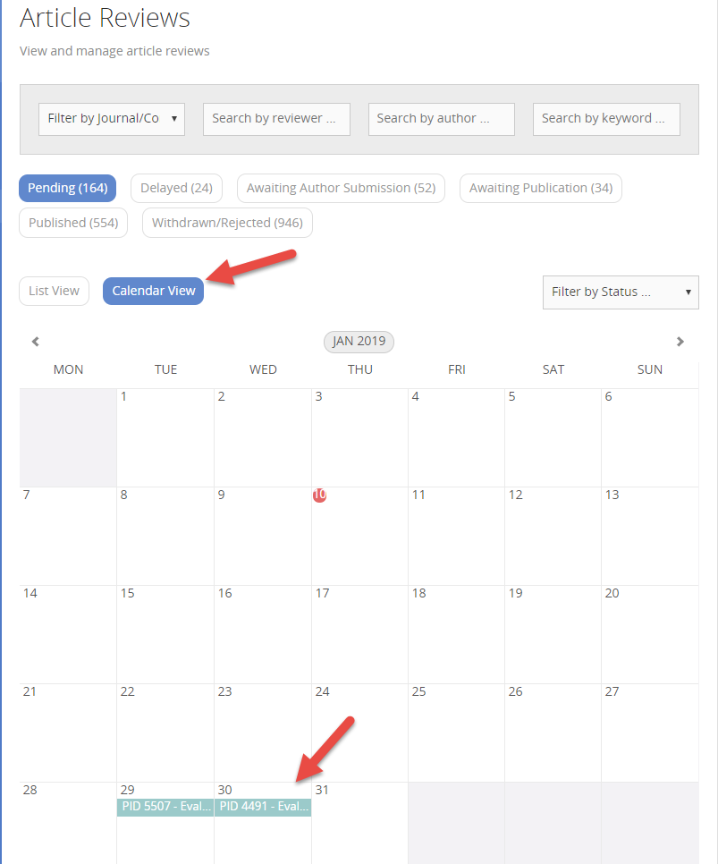
Figure 15. Keeping track of papers in the Calendar View

If there are insufficient reviews and you need to appoint more reviewers, you will need to change the due date for both the reviewers (in two weeks) and the editor (in four weeks) to keep the system happy and to enable it to continue to send reminders to reviewers at the appropriate dates. The system sends a letter to all reviewers advising the new due date. Note that editors are not able to assign reviewers and they can’t change the due dates for the initial review. Once an editor submits a recommendation, however, the system will not allow existing reviewers to submit a review or allow the EiC to add new reviewers.

Decide: The decision process
When the paper's Editor recommends an action and enters comments for the author into the system, the system waits for you to review these actions. No acceptance, acceptance pending, or rejection takes place until you or another Editor-in-Chief review the recommendation and the letter.

Review the comments to be sure that the editor used the appropriate template.

Except in rare cases, the development portion of comments should have been pasted into the appropriate template. The system does allow the Editor to upload a file. This option should be used rarely and only when development letter cannot be properly copied and pasted.
The upload option works best for PDF files, but also for DOCx files. You will need to test to verify that the files are readable.

If all is well, you can approve the comments and recommendation to make your decision. If you approve the editor's action, the system will email all.

Or, you may choose to have the system send the recommendation and letter back to the editor to re-do.

Or, you can enter your own letter or decision. Just keep in mind that your actions are not reviewed by another else.

Rate your editors’ performance
You and your fellow EiCs across all ISI journals help us develop our ISI editors. You do this by rating the quality of the editor’s work for each paper. When you do, you also provide the editor with brief feedback about their editorship that the system emails to the editor. The rating you provide makes it possible for us to identify editors whose work needs improving and those whose work needs commendation or promotion. Our goal is to help all editors to develop their skills and to identify excellent editors for acknowledgment and eventual promotion to Associate EiC or EiC. We rely on you and your fellow EiCs to provide us with quality feedback about editor performance.
Almost all editors earn a ‘3’, exceptionally good editors earn a ‘4’ or ‘5’, and those found lacking earn a ‘2’ or ‘1’. This rating is used by all ISI journals to identify which editors can use more training and which to commend for their excellence and possibly promote. As you rate each editor, provide the editor with brief feedback on the quality of their development letter and possibly how future development letters can be more suitable.

When you accept a paper for publication, the author/s can make no further changes. The system notifies the publisher that the paper is ready for final quality assurance and publication. The publisher then reviews the paper and checks if it is ready for publication. She may contact the authors directly to check on or ask for information, such as references. Usually, the paper will be online within two weeks.

Accepting for publication
When you accept a paper for publication, the author/s can make no further changes. The system notifies the publisher that the paper is ready for final quality assurance and publication. The publisher then reviews the paper and checks if it is ready for publication. She may contact the authors directly to check on or ask for information, such as references. Usually, the paper will be online within two weeks.
Once you accept a paper for publication, encourage (but do not require) the author to deposit any data gathering instruments they created (such as scales) as well as their raw data to be stored alongside their published paper. They do this by forwarding such additional documents to the publisher (Publisher@InformingScience.org). Doing so allows our journals to fulfill the ISI mission to “set knowledge free” even better. Our mission is to make research more freely available to scholars worldwide, and to assist other researchers in using these instruments and data in their own research (and cite the author). Such files will be stored with the paper and accessed on the paper’s landing page. Depositing the raw data (and SPSS files) also allows readers who so wish to re-analyze the data, and depositing the author-constructed survey instrument enables fellow researchers to re-use the survey. Note, however, that authors should review their university’s ethics approval (if applicable) before deciding to make data publicly available. Some universities will not permit the use of data collected without prior permission of research participants and/or approval by an ethics committee. If authors have any uncertainty about these, please advise them to discuss these issues with their university’s ethics committee.

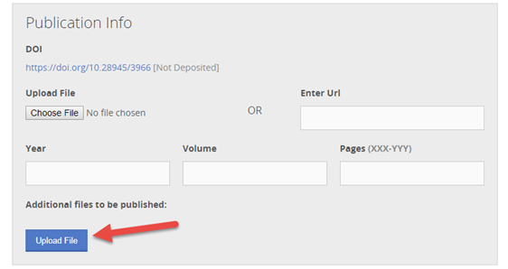
Figure 16. The Publisher can upload additional files to accompany the published paper
Now you know how to use the system to shepherd a submission from when you are first notified of it until you have completed the entire review process.

The Leadership Ladder: Adding, Promoting and Acknowledging People

Adding reviewers: A better way for determining the fit to review for your journal
We all have the experience of just looking at the resume of a potential reviewer for our journal, finding it suitable, accepting the person for the review board, and finding that the system rarely finds that the reviewer matches the papers submitted. This is because the reviewer selected too few topics of interest and expertise that match the topics by which the journal matches papers with reviewers. And some potential reviewers volunteer for multiple journals, only a few of which match their topics of interest.
However, the system shows the potential reviewer their match to each journal. In this way, the system lets the reviewer know that they are not a good fit to join the review board.
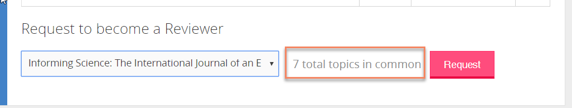
Figure 17. The system indicates a potential reviewer’s match to the journal
When you, as the Editor-in-Chief, receive a request from a potential reviewer to join your review board, the system shares this fitness information with you so you can decide whether or not to add the reviewer to your board.
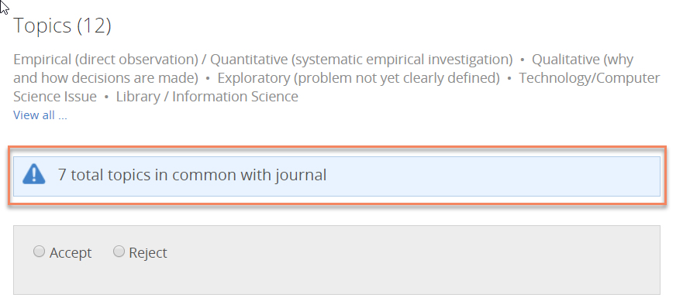
Figure 18. Deciding to accept or reject potential reviewer
We keep track of how many times a person requests to join the board of each journal where the EiC declines that request. This is useful information since a few people continue to re-apply to join or rejoin a review board. The reviewer’s details page displays the total declined requests by journal.
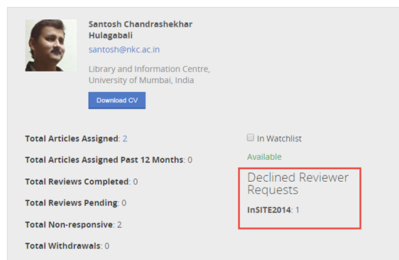
Figure 19. Reviewer’s page shows the history of declined requests
Your “accept or reject reviewer request page” also shows you if the colleague has previously published with us. If so, the volunteer is likely to understand the types and quality of reviews we expect.
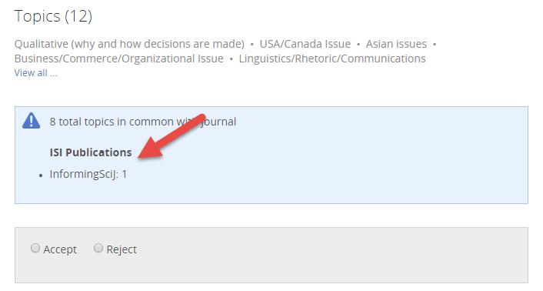
Figure 20. The system shows the number of the reviewer’s previous publications in any of our journals.

Learn more about your reviewers
The system provides you with a great deal of information about your reviewers, as seen in Figure 24. This information includes how many papers the reviewer currently has on assignment, the total number of reviews completed, how many times the reviewer failed to respond to a review or withdrew from a review that was assigned, and more. The Average Scoring Deviation is a comparison of how this reviewer’s ratings compared with other reviewers. A high score (say, above 25%) means the reviewer generally rates papers much higher than other reviewers, and a low score (say, below 25%) means the reviewer tends to rate papers much stricter than others.
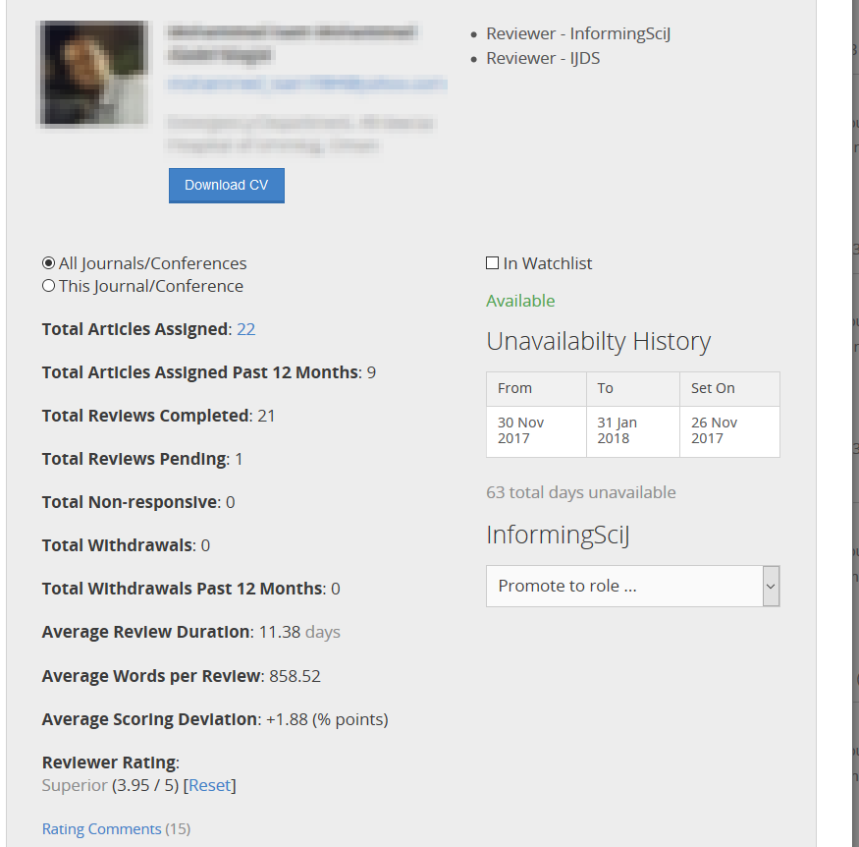
Figure 21. Information available about reviewers

Promotion across levels (Associate to Senior) and between levels (Reviewer to Editor to Editor-in-Chief)
One of the Informing Science Institute’s core principles is to mentor our colleagues to become better and better, better as an author, as a reviewer, as an editor, and even better as an editor-in-chief. When an EiC approves new reviewers, the system appoints them as Associate Reviewers initially. When an Associate Reviewer has completed two reviews, the system will notify the EiC with an email that asks if they wish to promote the Associate Reviewer to Reviewer. Thus, you can better focus your attention on mentoring the newest reviewers.
Those who serve successfully as a reviewer for us understand and embrace our philosophy as well as how to use our paper review system. One way to express thanks for jobs well done is public recognition. We do that by promoting from associate to full to senior levels of reviewer, editor, and editor-in-chief, and showing the promotions on our public website.

Reviewer Certificate for ISI Members.
As one of the many benefits of being a paid member, ISI Members can have the system generate a Certificate certifying their service as a reviewer. If you are not yet a paid member of ISI, step up to Membership at http://Member.Informingscience.org
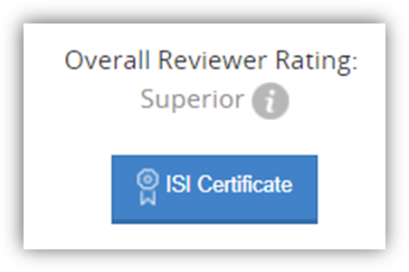
Figure 22. ISI Certificates for reviewer and editor high performance

Offering excellent reviewers a promotion
From time to time, as Editor-in-Chief, you will review the performance of all reviewers and offers promotions from Reviewer to Senior Reviewer and Associate Editor.

When should you promote people?
There are no hard and fast rules on when to promote. In part, it depends on whether you need more editors (and more associate editors-in-chief). Here are some indicators for you to consider:
- number of reviews (for a given journal, for all ISI journals, for the last year, overall)
- quality of reviews
- number of journals reviewing for
- number of withdrawals (overall time, for the past year, for this journal, for all ISI journals)
- number of non-responses to requests to review
- length of service to ISI
- length of time in current position (as an associate, full, or senior), but the most important consideration is:
- “Do you trust this individual to take the job of mentoring others seriously?”

Promoting and mentoring reviewers and editors
When indexing services review the quality of a journal, we learned the hard way that they look at who is on the board of reviewers. Therefore, from time to time, the Board of Governors will send you suggestions on promoting, training, or removing members of your board. There are three main categories:
- Non-performing reviewers and editors.
Some individuals on your board will consistently display poor performance. These reviewers (or editors) need to be mentored by you. You should initially add them to the watchlist and, if necessary, prune them from your review board. You can sort your reviewers’ ratings on the Reviewers tab (click “Order by Score”). Click the X box to the right of the reviewer’s name to remove the reviewer from your board. You (or, if you prefer, the Managing Editor) should email such reviewers or editors a “Goodbye” letter (template available in Your Notepad) with an invitation to rejoin the review board when they have time to be actively engaged.
It is important to prune away non-performing reviewers for two reasons. First, the editors of papers are quite unhappy when they are left with only one or two quality reviews to use when creating their development letter. Second, including on the review board colleagues known to be low-quality reviewers diminishes the reputation of your journal.
You can use the reviewer data that the Board of Governors sends you to prune your review board of non-performing reviewers. You can use your own dashboard’s data on reviewers to examine the performance of your board members. For example, you could look at the number of times a reviewer didn’t respond using the link at https://www.informingscience.org/Member/Reviewers?Tab=All&SubTab=Reviewers&UnavailableTab=&BoardRoleFilter=&Search=&OrderBy=TotalNonResponsive
- Reviewers and editors who need more guidance from you
Email a copy of the Reviewer Manual to these reviewers, and the Editor Manual to these editors, with a letter expressing your wish for more helpful and mentoring reviews (or Decision Letters) in the future. You are their mentor, and they need your guidance.
- Excellent reviewers and editors
Send excellent reviewers a thank you letter. Good work deserves to be acknowledged. You may wish to acknowledge consistent good work as a Reviewer with a promotion to Senior Reviewer (an honorary advancement).
If you can use help as EiC, offer a promotion to Associate Editor-in-Chief. This job is not for every excellent editor since it requires a higher level of commitment and additional skills in mentoring editors.
For your letters, you need not re-invent the wheel. The Board of Governors provides you with Best Practice templates for each of these categories. You will need to copy them to your email and personalize your emails. Pay attention that you will need to fill in the placeholders manually with actual names and such.
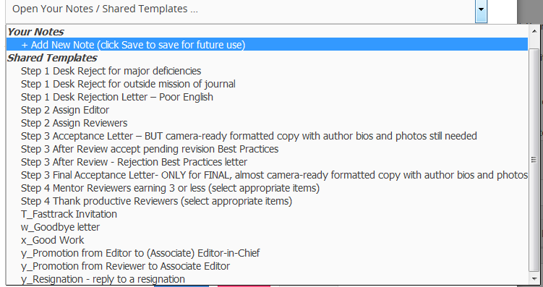
Figure 23. Best Practices letters for mentoring and promoting reviewers and editors
You can also monitor reviewers and editors by clicking on their name in the Editorial Board menu. There you will find the data shown in the reviewers' tab. This will assist you in acknowledging and promoting the excellent reviewer, in training reviewers who need training, and in saying goodbye to those reviewers who are not contributing. We show you not just wording (Outstanding, Superior, Average, More Training Needed, and Unhelpful); we also show average rating numerically. The actual number allows you to note, for example, that Superior (3.50/5) is not that different from Average (3.33/5).
The EiC is able to view statistics regarding editors’ past performance of accepting/rejecting, how reviewers’ acceptance differs from the average, and A/EiC tardiness. The reviewer scores in the Details view and in the Dashboard are normalized to a percentage, so the average scoring deviation is expressed in points out of 100 (Figure 27).

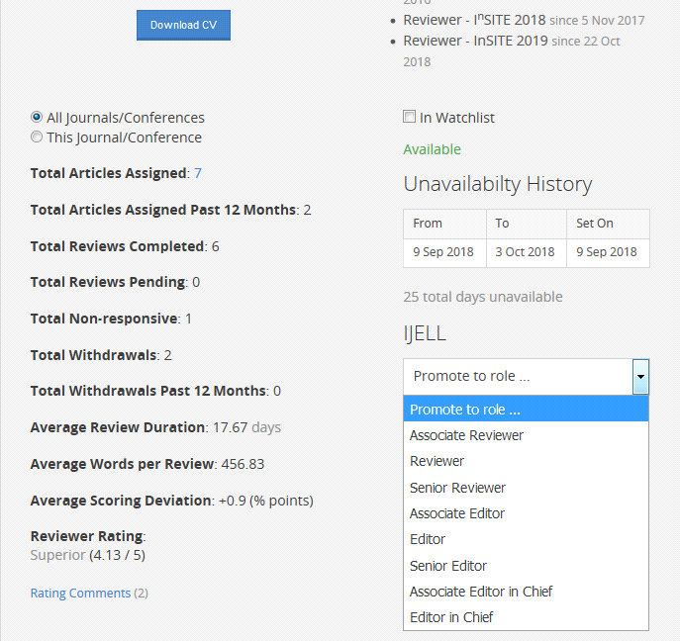
Figure 24. Checking data and promoting reviewers/editors.
The reviewer above writes excellent reviews (average rating by the editors of 4.13/5)
and rates papers very similar (less than 1% higher) than the average of each paper’s other reviewers.
You can see what editors wrote to their reviewers (Figure 28). This allows you to mentor them if need be, and this will help you improve your ratings of editors. You should review both the ratings and letters to confirm that your editors are following ISI policy. Typically, the reviewers’ rating should be between 3 and 4, and the feedback to individual reviewers should be customized to that reviewer’s performance. These comments to reviewers by editors are stored for future viewing in the reviewer’s profile (Figure 29).
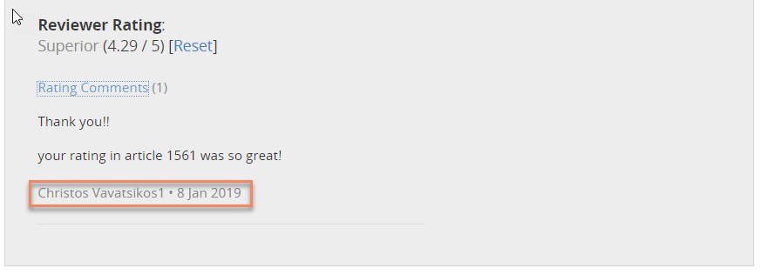
Figure 25. Check editors’ comments to their reviewers

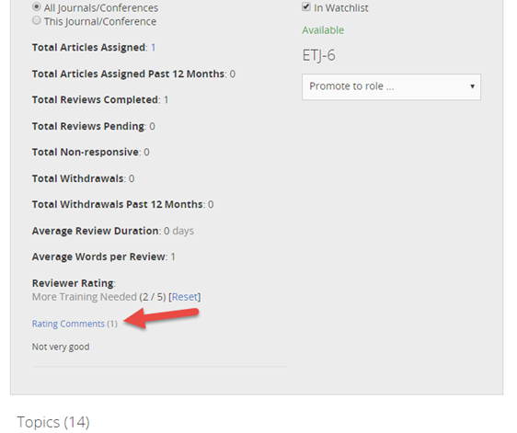
Figure 26. Comments to reviewers are stored in the system
Figure 30 is an example of really bad feedback by an editor.
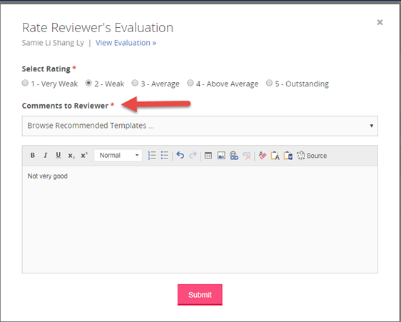
Figure 27. Example of poor feedback to a reviewer
Here are some suggested words for editors to use in feedback to a good reviewer:
- I appreciate and thank you for the positive way you worded feedback for the author on how to improve the paper. Your phrasing builds up the author through supportive and constructive language. This is the way I would like suggestions on my papers to be worded. Great job!
- Your review provided the author with concrete ideas on how the submission can be made even stronger.
- It is obvious that you shared generously with your valuable time and considerable skills to help your colleague improve the paper.
- Your insights provide the author with ideas for new ways to take the paper.
- Thank you for assisting the author by suggesting specific additional references to strengthen the paper.
- Your suggestions on organizing the paper are great.
- I appreciate your using line numbers to show the author where to make improvements.
And some suggested words for editors to use in feedback to a reviewer who needs mentoring:
- You should write your review as if you were writing directly to the author and not to me.
- Aim to phrase your comments in a way to help and build up the author through supportive and constructive language. Phrase your review to criticize the paper, not the author, perhaps using phrases like “Your submission will be even stronger by …”.
- We understand that your time is valuable; we ask that you be even more generous with your time and considerable skills to help your colleague improve the paper. We ask for well-formed paragraphs of suggestions, so please use complete sentences to share your ideas with the author.
- Your future reviews will be more useful to the author and me by including concrete ideas on how the author can make the submission even stronger.
- The role of the reviewer for this journal is that of the coach, not the referee. Share your thoughts on how to improve the submission if the submission has problems.
The system lists the Editor’s rating as editors as well as their ratings of a reviewer (Figure 31).

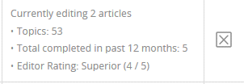
Figure 28. The system stores your ratings of each editors’ performance
More about promoting excellent reviewers to editors. The process is first to offer promotion since not every excellent reviewer wants to become an editor. Serving as editor is not suited for every excellent reviewer since the job requires a higher level of commitment and additional skills in writing mentoring letters.
Adding new reviewers to your Board. The system also eases the burden of signing up new reviewers. The system doesn’t decide whom to accept or not for your board, only you do, but it helps speed you through the process.
As time goes by, you will lose reviewers. Some you will promote from reviewer to editor, some will retire from academia, and some you will let go for poor performance. The system allows journals to accept (or not) new requests to join the review board. By default, ISI journals do allow new “requests to join the review board,” but you can turn off listing your journal as accepting new reviewers.
Your best reviewers will come from authors of papers you publish. They already have some familiarity with the ISI Paper Review System, and you know that they have published at least one paper suitable for your journal. The publisher invites them to join your board in her acceptance letter, but you can also follow up with your personal request to join your journal’s board.
When someone requests to join your review board, the system requires them to fill out their profile, upload their CV, and select topics on which they have interest and expertise. The system then notifies you that there is a reviewer request pending. Click on the link in the email to go directly to the request. You can also see outstanding reviewer requests by clicking on the Reviewers tab on the left menu (from your dashboard) and then the Pending option on the right. The request link will have a copy of the applicant’s CV as well as other useful information, such as whether the applicant is a reviewer for other ISI journals or conferences.
You decide whether to accept the applicant into your board. Read the CV to assess the applicant’s suitability for your journal. Read any notes about this individual, particularly if they are on the Watchlist. If they have any statistics in the system as a past reviewer, see how prior editors rated their performance. Also, see if the applicant’s self-selected topics fit within your journal’s scope and if the applicant has scholarly publications. The system makes it easier to evaluate the fit of the applicant to your journal by showing you the number of topics on the reviewer’s list of topics of interest and expertise that match to your journal. You want to select people for your review board who have published in your field and who have selected a large number of topics matching your journal’s topics.
Use the system to select your decision, “Accept” or “Reject,” and fill in the comments for the applicant. We have placed some templates in your Notepad that you can insert and modify to fit the situation. The templates are: (i) reject as not a match; (ii) reject for lack of publications; or (iii) accept (welcome). You can preview the letter to ensure the correct information has been inserted in the placeholders. Note, in particular, the signature, as the default is to insert the current user, who may be the AEiC on behalf of the EiC.
We recommend that you keep track of new reviewers for the first few papers with an eye toward mentoring them. When you are satisfied with the new reviewer’s performance, promote them to regular reviewers. Everyone enjoys being promoted.

Promoting Editor to AEiC
The process for promoting excellent editors to AEiC is similar but involves the Executive Director since it involves changing the former editor’s dashboard to an EiC dashboard, as well as training. The AEiC’s dashboard is the same as the EiCs, so making a mistake on this dashboard can have dire consequences.

Promoting Reviewer to Editor
When you first promote a reviewer to be an editor, the system issues the title of Associate Editor. The newly promoted associate editor needs some training and guidance. We have created an Editors’ Manual for new editors.
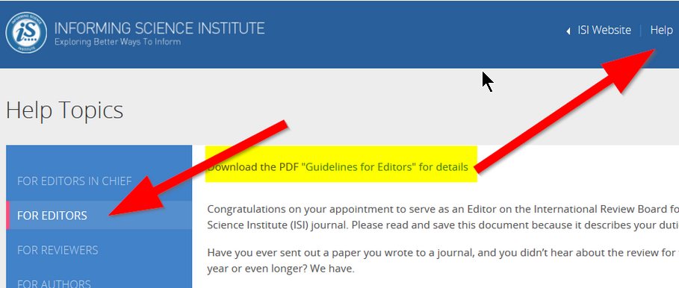

Give a pat on the back to excellent, experienced Reviewers and Editors
Remember that you can and should promote reviewers and editors to Senior Reviewer and Senior Editor from time to time. The system treats Reviewers and Senior Reviewers the same in terms of their roles and duties; the difference is the prestige. On the public website, the word “Senior” is shown on the Board Member page, for example, https://www.informingscience.org/Journals/IJDS/BoardMembers. On the colleague’s dashboard, the title shows where the role is displayed. (The same is true for Editor and Senior Editor.)
You need to mentor those you promote. Reading the manual is a good start, but for the first few assignments, your job is to monitor the new editor (or AEiC) closely until this initial training has been completed. Then promote the associate editor to full editor. You can do this if you want to stay on as EiC and share the load.

What about promoting yourself to senior editor-in-chief?
Once you have at least one other full editor-in-chief who has served as EiC for perhaps a year, you may wish to take on a more supervisory role as Senior EiC. The Senior EiC focuses on recruiting new authors and papers, supervising and mentoring the members of the Board of Reviewers, finding external funding, and otherwise promoting the journal. Our system has a feature that so far has gone unused, which allows senior EiCs to limit the AEiC access to just a selected portion of the full EiC menu, such as to review new submissions.
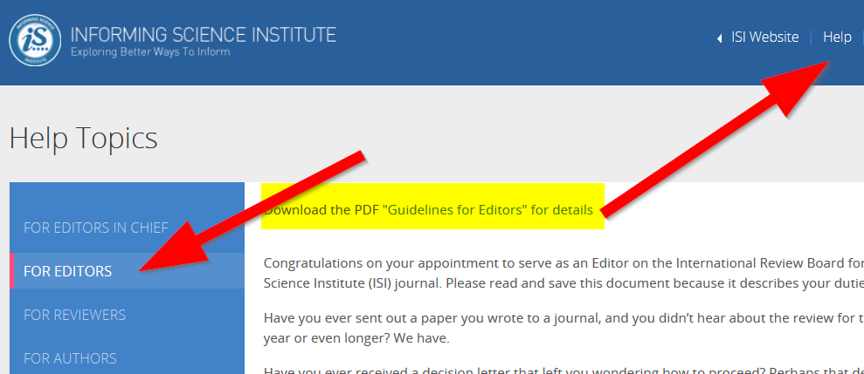
Figure 29. Where to find the Guideline for Editors and the link to download the PDF version

Acknowledging people
Each month, ISI honors a Reviewer of the Month and an Editor of the Month. The system displays these honors on the Community page. The page initially displays the most current Reviewer and Editor of the Month and will show all by clicking the View All link under each photo. ISI Members have all certificates stored in the system: membership receipt, reviewer badges of achievement, old ISI Reviewer Certificate, and reviewer/editor of the month, yearly awards/badges. ISI members can print their certificates.

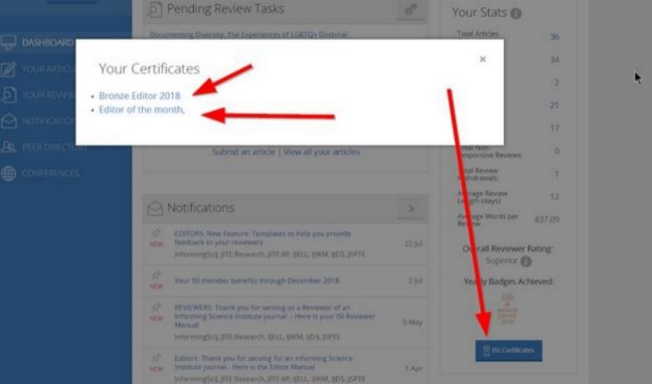
Figure 30. The system stores ISI members’ certificates

Fast-Tracking Papers from InSITE to your Journal

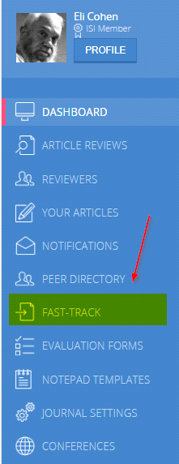
We encourage you to fast-track all excellent papers submitted to InSITE since publishing high-quality papers helps your journal and helps the conference. Use the Fast-Tracking tab on your dashboard to invite InSITE authors to accept your offer to fast-track their submission to your journal.
Fast-tracking means that you use the reviews provided by the InSITE reviewers to pre-approve the paper for publication in your journal and tell the author that the only changes you require, if any, are those that you describe in your development letter. Or, you can write the fast-track offer to indicate that the paper will go out for review by your journal's review board as a new paper.
You will receive an email from the system with a list of externally reviewed InSITE papers, a link to the original submission, a link to the raw reviews, the number of reviews, and our thoughts of a home for this paper based on its title. On your dashboard (under Fast-Track), you also have links to download two additional documents: the revised paper and the revision document.
The list is sorted by average reviewer rating, but you know to take these average reviewer ratings with a large grain of salt. Since reviewer ratings are unreliable measures of quality, look for the reviewers’ suggestions for improvement. Reviews are of various qualities, and some reviewers rate all papers high or low. The list also shows whether at least one of the authors has already paid the conference registration fee. We publish fast-tracked papers if at least one author is a delegate to the conference. This requirement ensures that fast-tracking does not short-cut your own journal’s review process.
When you click on the selection box next to a paper, a new “Fast-Track to” comment box will appear at the bottom of the screen, like the one shown here as a screenshot. You will need to scroll down to see the newly opened box. The Notepad in that box now contains the new template with wording to get your invitation letter started. If you like the wording, you need only add what changes you require and enter the name of the journal.
The secret box at the bottom of the Fast-Track tab that appears once you check the box next to your choice can be confusing. There are many, many InSITE papers from which you can choose. Once you select one, a new box (like the one here) pops up on the bottom of the window. Just select your journal, change the REPLY BY date if you wish, then from your NOTEPAD select the T_Fasttrack Invitation template, add any conditions you wish, and click the Submit button.
While you can change the Reply Expected date, keep the date within a week. The author may hope to receive an invitation from a different one of our journals and, until the expiration date passes, no other editor can offer fast-tracking for this paper.
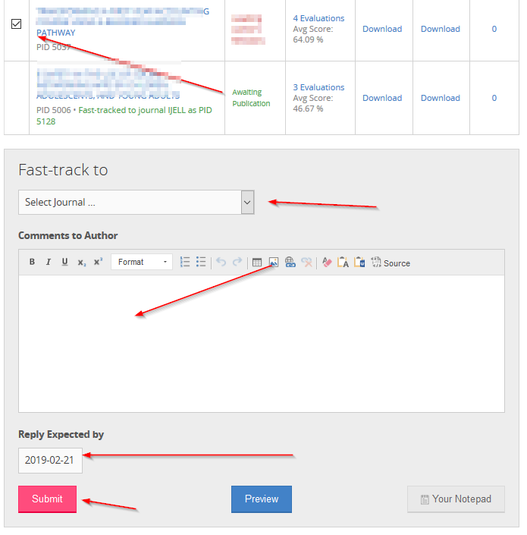
Figure 31. Fast-track process: select a paper to fast-track, select your journal, then fill in the comments for the author. These comments should tell the author exactly what revisions you will require for publication since, by definition, fast-tracked papers do not undergo additional review.
The system emails the author and, if the author accepts your invitation from their dashboard, the system places a copy of the paper in your journal’s queue, marked as “fast-tracked from InSITE.” It looks like this:

[AUTHOR-NAME],
Thank you for the high-quality submission PID [ARTICLE-ID] [ARTICLE-TITLE] to I^{n}SITE and for revising it the submission in light of reviewers’ suggestions. I have reviewed your initial submission, your revision, and your revisions document.
On that basis, I am pleased to offer you the opportunity to fast-track your I^{n}SITE submission to the journal I run, ________)
If you accept this invitation, your paper will automatically be submitted to my journal and given a new paper ID (PID).

(optional)
While your revised paper is quite good, I do require the following revisions to make your paper suitable for publication in the journal.
(list of changes required, if any:
1.
2.
3.

select this paragraph......
Fast-tracked papers do not undergo additional review by outside reviewers and instead are reviewed by the Accepting Editor.

OR select this paragraph ...
I would like to have the paper re-reviewed by the journal's reviewers. By accepting fast-tracking, the paper will be automatically submitted to the journal and you will have the paper reviewed again by the journal’s International Board of Reviewers.

Follow the link in this email to accept or reject this invitation. Note that invitation does expire.

[CURRENT-USER-NAME]
Editor-in-Chief
[CURRENT-USER-EMAIL]
The offer to fast-track, including this development wording, is saved by the system in the activity log, where you can later view it to determine whether the revised paper meets the requirements you set down in that invitation letter. If the author declines your offer to fast-track, the activity log of the original article stored the author’s decision against fast-tracking.
Understand that the fast-tracking invitation means that you have accepted the paper for publication so long as the author complies with this conditional acceptance letter. In other words, fast-tracked papers do not go out for external review unless your invitation letter specifies that it will go out for another round of reviews by the journal's review board.
To process a fast-tracked paper through the system, you will be skipping steps. If the author accepts your invitation, the paper shows up in your journal’s queue as a fast-tracked paper. You, as the Editor-in-Chief, will serve as the paper’s editor. Skip all intermediary steps from desk accept until the last step. Then “accept the paper pending revision” and use the template “T_Fast track_ invitation,” filling in the changes needed for acceptance.
If you don’t ask for any changes, just ask the author to format the paper. If you do ask for additional changes, restate those revision requirements in your T_Fast track_invitation” comments to the author and ask the author to format the paper to your journal’s specifications.
What if? It’s rare, but it does happen. If the author does not make the changes you required in your invitation letter, you can reject the paper. To do this, email the Managing Editor who will instruct the system to withdraw the paper from your queue due to author non-compliance and will note this in the author’s record. The rejection is stored in the activity log of the original article. Figure 35 shows some short wording as the description. Your development letter will be placed here.
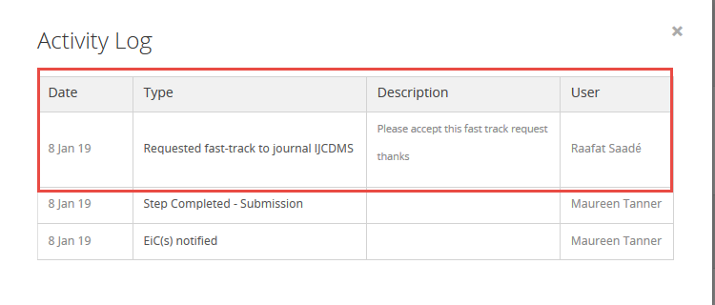
Figure 32. A simplified example of seeing your fast-tracking offer in the submission’s Activity Log

Common Issues

Making an A/EiC the paper’s editor
Sometimes the A/EiC must take over a paper from an Editor:
    - On Step 3. Editorial Board, in the Select Editor section, click Reset at the bottom of the page and then click the red SET EDITOR button.
    - Change the name in the notification letter to the A/EiC’s name.
    - Click SET EDITOR.
    - Notifications will now go to all A/EiCs

Assigning a different editor
There will be times when the editor to whom you assigned a paper is unavailable. In that case, you will need to assign the paper to a different editor.
To unassign an editor and assign it a different editor, on Step 3. Editorial Board, in the Select Editor section,
- click the radio button of the editor to whom you will be assigning the paper.
- change the name of the editor in the Instructions to Editor field. Otherwise the system will send the email to the new editor with the old editor's name
- Set a later Editor Due Date (if needed), change the name in the , make any other changes to the letter you feel are necessary, and click Save to send the letter to the editor.
- click the red SET EDITOR button located at the end of the page.

Authors making extensive revisions that require a new review
Occasionally, there are instances where authors make such drastic revisions that the paper is essentially a new paper. The editor recommends that the paper should be reviewed again as a new paper.
If you agree, first, you fill in the Comments to the Author with the reason and select “Requires more revisions.” Tell the author that when resubmitting the paper, it will need to have a slightly different name since the system checks for accidental resubmissions.
Second, email Managing Editor Eli Cohen with that note (including the PID of the paper), and he will include it in an email he sends to the author about the withdrawal. The system sends a copy of the email to the EiC, the editor, and the reviewers. The author will get copies of why you withdrew the paper.

Two useful system features: Activity Log and Notes (on this paper)
Each paper has its own Activity Log and Notes that you and the editor can view, located on the paper’s page towards the top of the screen.
- The system keeps an activity log for each paper that records all decisions and communications made through the dialogue box. You can review all this activity by clicking on the paper’s Activity Log. This is a useful tool since it shows all system activity for this paper.
- Use the Notes feature to post comments related to the review process. These notes are shared only with the editor, AEiC, and you. Since the activity log doesn’t show private email conversations that you had with the author, reviewer, or editor, put a copy of those emails, or perhaps just important paragraphs, in the paper’s Notes. The system emails these notes “upward”; that is, the EiC is notified by email when an editor creates a note, but not vice versa. To contact an Editor, we ask EiCs to email the editor outside of the system and, in the Notes, indicate that they have done so.
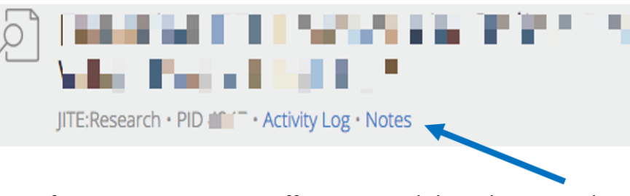
Figure 33. The Activity Log and the Notes features

Changing the Due Date for a paper
The system uses the target date to specify when to send out reminders. Sometimes an author or reviewer asks for an extension, and you or the Editor approves it. When that happens, you need to remember to tell the system the new date, or it will continue to send out overdue reminders based on the old date. Change the target date for editors and reviewers from the Editorial Review tab. Note that while ISI journals do grant more than one extension for authors to submit their revisions, ensure that the request is legitimate and reasonable.
Change the author revision due date from the Decision tab by clicking on the pencil icon Remember to click Save after making the change! The system will then send out reminders close to the new target date.

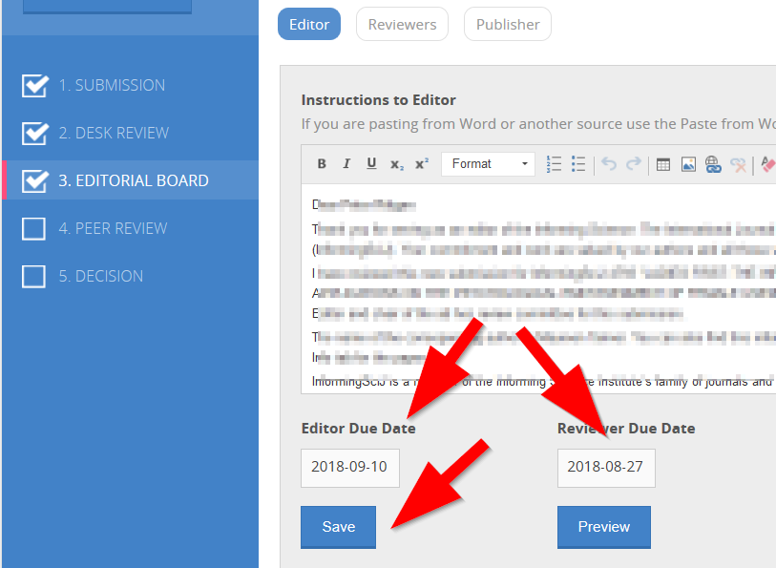
Figure 34. Change the Editor and Reviewer from the Editorial Board tab

Professional misconduct
If you believe that a paper fails to follow professional ethics, such as with plagiarism or self-plagiarism, do the following:
- Do not reject the paper. Instead, let the paper stay in the queue. While it is in our queue, email the Executive Director of your concern and, in that email, provide all the evidence you assembled. The Board of Governors’ policy directs the Executive Director (ED) to investigate such cases.
- Do not put yourself at risk by accusing the authors of anything. You can and should ask the author for information; don’t accuse. You could use wording such as:
I noticed that the paper you submitted [PID] was previously checked for similarity with other papers and so entered into a database maintained by TurnItIn. On the face of it, this looks like you submitted a paper written by another.
I need your help to clear up this matter. Please provide me with an explanation by [DATE] why your paper is shown in the Turnitin database. If you need a bit more time to submit your explanation, just ask. Be sure to attach to your explanation whatever documentation that you can add.
- If the response is not satisfactory, email the ED (see https://www.informingscience.org/Community/ISITeam) to ask the ED to open an investigation. In your email to the ED, provide full and detailed information with copies of the documents your internal investigations already uncovered. This might include copies of the “other” paper and possibly an annotated copy of the submission that shows duplication. The ED will prepare a report for the Board of Governors, and that body will decide if professional sanctions are to be imposed.
What you need to know about Corresponding Authors. Before we leave this step, know that once the corresponding author submits the paper, the system emails only the corresponding author. Co-authors see all the information about the paper in their dashboard, but only the corresponding author can upload revisions.
From your dashboard, you can change which co-author is the corresponding author, change the order of co-authorship, delete a non-corresponding co-author, and even add a new co-author, as seen in Figure 38. Do this only rarely!
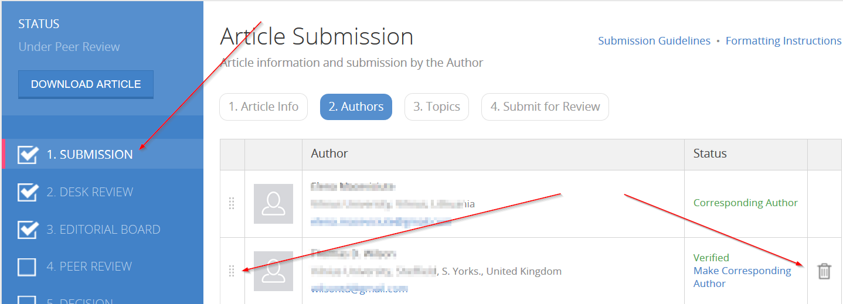
Figure 35. From the SUBMISSION tab, you can see the author's information,
change the order of authorship, delete an author, and add a new co-author. But read why you shouldn’t do this.
If the authorship changes, contact your Managing Editor. Since the system does not send verification emails to the co-authors that you add, do this only if you receive an email from the co-author asking to be added (see coauthor_letter).
In summary, when a “corresponding author” submits a paper, the author has already filled in details of any co-authors (Step 2) and then filled in the paper topics (Step 3). Each co-author then receives an email asking if they accept co-authorship. Once all co-authors verify their co-authorship, the corresponding author will be able to submit the paper. This step is necessary to ensure that co-authors don’t submit the same paper to a different journal and accept co-authorship. After the author has completed all the steps, the system notifies you that you have a new submission to download and review.

Common Questions

How do I recommend an improvement to the system?
To suggest an improvement to the system, submit your idea, as shown in Figure 39. Click Feedback, then Submit Feedback, and then fill in the form. The system keeps track of all such submissions.
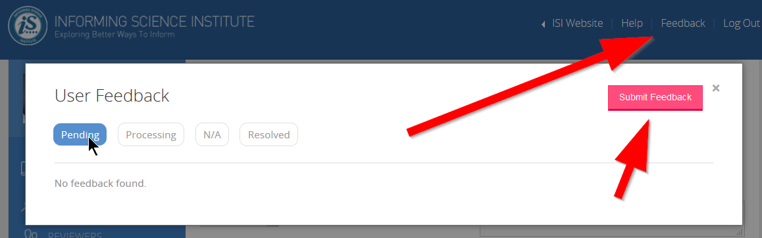
Figure 36. How to submit feedback on desired features enhancements

How often is the system upgraded?
Bugs are fixed as soon as they are reported, often within hours. New feature and feature enhancement requests are assembled and prioritized periodically, currently twice a year. The highest priority is given to changes that affect most people.

How does an author get help with a review or submission?
An author or potential author can click on the Feedback button at the top right of the web page and select Help with Article Review and Article Submission. The system asks the person to identify the paper to which they are referring, by PID or title.

How does a reviewer withdraw from an assigned paper?
The reviewer needs to log in at http://My.InformingScience.org, click on the paper’s title, and, on the reviewer page, click Withdraw. The reviewer must withdraw before downloading the paper to prevent “picking and choosing” which papers to review. Withdrawing tells the system not to send reminders. The editor cannot withdraw a reviewer from the paper’s review board; the reviewer has to do that. To prevent being assigned a paper, reviewers can, from their dashboard, indicate the dates of their unavailability. In their dashboard, reviewers also can select the number of days between review assignments to prevent being assigned to review several papers during a period.

How do I add a new editor to my board?
To appoint a new editor, contact the Managing Editor. ISI’s policy is to invite the best ISI reviewers to become Editors. To do the job of being a mentoring editor properly, the person must know what ISI journals expect of their reviewers. And the editor needs some training. Appoint the new editors as Associate Editors for the first review or two, while you closely help them learn the ropes. Then you can promote the person from associate to full editor. We even offer the title of Senior Editor to reward the best editors.

Why doesn’t the system display an editor or reviewer?
When an editor or reviewer sets their status to “unavailable,” they do not show up on the public website and cannot be assigned a paper.

How can I email all reviewers and/or all editors?
You can download all reviewers’ and editors’ email addresses and send them a personal email. Go to the Reviewers tab, scroll down to the bottom of the page, and click on Export Emails. To preserve privacy, copy and paste the list to the BCC line, and on the TO line, insert your own email address.

Figure 37. Reviewers’ and editors’ email addresses can be exported

An author emails me that the system will not let her/him upload the revision: what do I do?
Only the corresponding author can upload revisions to ensure that you receive only one version of the paper. If the current corresponding author agrees, you can change who is the corresponding author in the paper. Go to the Step 1 Submission page, then the Authors tab, and click on Make Corresponding Author

What to do if your editor doesn’t respond?
The system emails several reminders to the editor you assigned to the paper. Not responding can happen for any number of reasons, including sudden illness. If the editor still doesn’t respond after a few weeks, you or a fellow A/EiC will need to take over editorial duties for the paper. We promise a prompt, courteous, and mentoring response to authors.

A paper received only two good quality reviews: what do I do?
Likewise, there may be times most of the reviewers assigned don’t respond with useful reviews. This is why we recommend assigning most submissions to 6-8 reviewers. Tell the editor to use the two good quality reviews with the editor’s own thoughts to create their decision and development letter. Then think about pruning off your review board those reviewers who fail to do their job.

What if an author doesn’t want to revise a submitted paper?
The author needs to visit the paper’s review site and let the system know. The author must log in using the link in the revisions email or log in directly at http://My.InformingScience.org and visit the Revision tab, click on No Intention to Revise, then click on Submit. Note: clicking on this button means that the paper is permanently withdrawn. To submit the paper again, it must have a slightly different title since the system prevents duplicate submissions.

What if an author does not submit a revised version after numerous reminders from the system?
The EiC can remove the paper from the system; the Editor cannot.

What if an author disagrees with the revisions required and refuses to make any changes?
Advise the Managing Editor who will remove the paper.

An author revises a paper that has been accepted but makes other substantial changes (e.g., to the analysis or model), can it be rejected?
Rejecting a “previously accepted subject to revision” paper is a highly unusual occurrence, but it does occur when the author is unable or unwilling to comply with the conditions set down in the decision letter. In this case, only the Managing Editor can withdraw a previously accepted paper since ISI wants this to be a rare occurrence. The Managing Editor uses wording such as:
“I am sorry to see that you are unable to comply with the conditions of the development letter. The revision that you provided changes the analysis methods and the model on which the study is based. Therefore, we are withdrawing your submission. It is best to have your submission reviewed again by a different set of reviewers. While I hope that you will submit your paper again to this journal, but you are now free to submit it to a different outlet if you prefer.”

What to do if you upload the wrong PDF?
If you accidentally upload the wrong PDF, contact the executive director to have her/him delete the old file so you can upload a replacement.
If you discover this after any reviewer has downloaded the file, you will need also to contact such reviewers to let them know that the submission they downloaded is incorrect.

After the author submitted a paper, the author wants to have a later version reviewed: what can I do?
The author cannot make any changes to a paper once it has been submitted. If you have not already sent the paper out for review, or if no reviewer has uploaded a review for it, you can use the new paper if you want. As always, blind it, add line numbers, and convert it to PDF. Then delete the existing PDF and upload the new PDF. Do this on the paper’s Desk Review tab by deleting the old PDF by clicking the x, uploading the new paper, and then clicking Save. See What to do if you upload the wrong PDF.
If reviewing has already started with one or more reviewers downloading it, you can email all the reviewers for the paper to hold off reviewing and ask the Managing Editor to delete the existing PDF so you can upload its replacement.
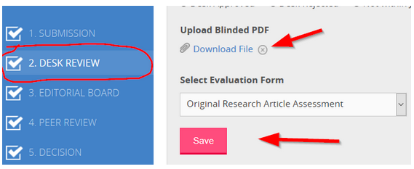

Why are the raw reviewers’ comments not released to authors?
We write a development letter that incorporates the wisdom of the editor enlightened by reviewers’ suggestions so that the author has a clear and unambiguous message on how to improve the submission. Doing so is particularly helpful since reviewers’ approach papers from their various vantage points and what one reviewer values another may devalue. Also, some reviewers need to be mentored on how to write constructively. It is the editor’s task to make sense of these different viewpoints and to place them into a constructively written development letter.

How does an author pay for a paper to be formatted?
To make a payment to ISI to hire someone as a formatter, visit http://Pay.InformingScience.org and follow the instructions. For the description, enter some wording like “Formatting fee for PID XXXX.” Note that this service is for formatting only. The formatter is not a copy editor. If a paper needs to be copy-edited (e.g., for grammar or to make the sentences make sense), the author needs to get this revision done outside of ISI before the paper can be accepted.

How many A/EiCs should I have?
The decision is the EiCs, but a rule-of-thumb could be one A/EiC for every 15 submissions per year.

I received a request from a non-ISI conference chair to publish their papers: what should I do?
Typically, this request comes from a less-than-reputable conference that collects money to get papers published in journals. The Board of Governors has a policy on this issue. The author (and not the conference chair) needs to submit the paper to your journal, noting in the paper itself that an earlier version of the paper was published in the conference’s proceeding and citing that paper, and it must have 30% or more change of a substantial nature; that is, not simply padding with more words. You then have the paper reviewed as normal.

Can my journal run a Special Series?
We can and do offer special series. Papers accepted for publication in the series are held back and published all at once. Typically, the special series editor(s) writes a forward that is published first, and all papers in the series published sequentially on the same day. Be sure not to accept a paper for publication until all papers are ready.

What does the "Peer Review is not Active at this point for this article" error message mean?
Suppose you assign additional reviewers, change the due dates, and your reviewers write they are receiving the error message "Peer review is not active at this point for this article"
What has happened is that your editor submitted a decision/recommendation letter. Once this happens, reviewing ends.
At this point, unassign the new reviewers so that their not providing a review is not counted by the system and conduct the remainder of their reviewing outside the system. Email them the paper and ask for their suggestions via email.

How to Delete a YOUR NOTES item from your template
If you accidentally create a template and want to delete it, there are two ways:
Way 1: Click the NOTEPAD TEMPLATES link (it is the third from last under Dashboard). Scroll down to Your Notepad Templates. Click the trash can icon next to the template you want to delete, as shown below.
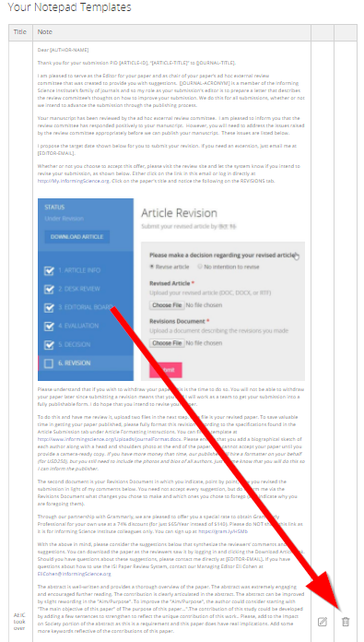
Way 2: When you next bring up NOTEPAD, for example when dealing with a paper, you can bring up the YOUR NOTES list and click to DELETE the button.
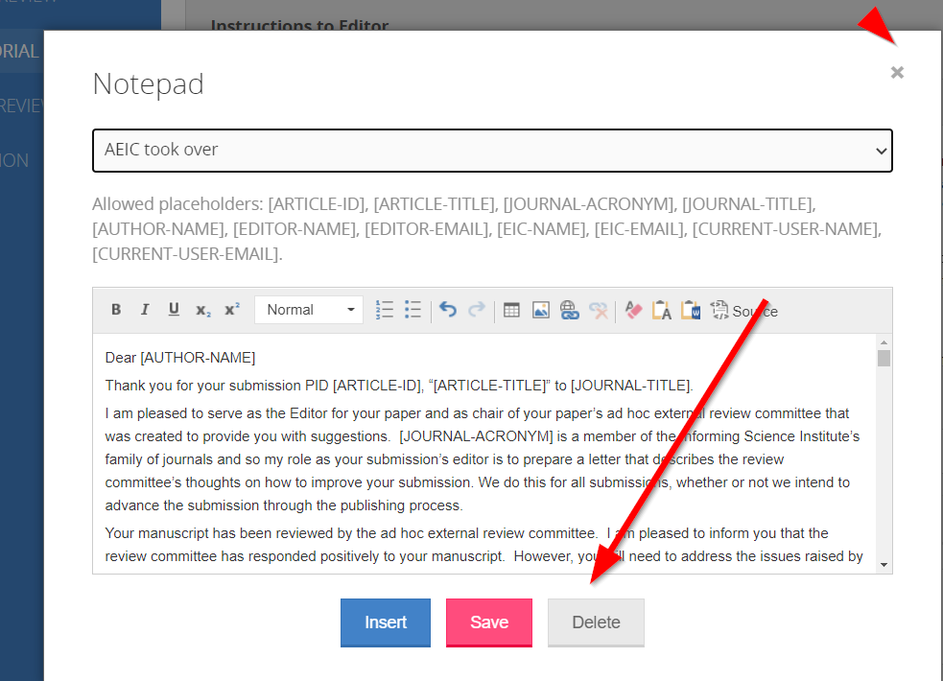

For Your Information

Author submission agreement
Here is the current draft of the author submission agreement. Corresponding authors affirm when they submit their paper.
By submitting your manuscript to this Informing Science Institute Journal, you affirm the following:
- This paper is not currently under review by any other publication, and you (and any co-author) will not submit it to a different publication until the paper is either accepted for publication or rejected. I understand that violating this stipulation is professional misconduct.
- This paper does not contain plagiarized or copyrighted material. I understand that violating this stipulation is professional misconduct.
- I have read and followed all of the guidelines for papers submitted, including blinding the paper.
- I understand that by submitting my paper, I retain the copyright, but my paper will be published upon acceptance of my paper for publication under a Creative Commons By-NC license.
- If your paper is a re-submission, be sure to indicate this to the Editor-in-Chief with the old and the new paper ID.
- There is no publication fee for ISI members. If a paper is accepted for publication, the corresponding author needs to be (or become) an ISI member or pay the equivalent of a one-year membership fee.
- I have read, understand, and affirm adherence to the Informing Science Institute policy regarding professional ethics Statement on our Expectations: Professional Ethics and Malpractice including its policy on how ISI handles ethics violations. I have also read, understand, and agree to the ISI Privacy Policy.
- I affirm that this submission complies with all the requirements of my university or employer, including the agreement of any human research ethics committee.
Figure 38. Informing Science Institute Journal Submission Agreement

Changing your journal’s defaults
Typically, you will not change the defaults for your journal. These features are useful for our partner journals (Figure 43). All journals, ISI journals and partner journals, have a Journal Settings tab available on the EiC’s dashboard where you can change the defaults. The only ones you might consider changing are for the maximum number of reviewers, reviewer due date, and editor due date. Do not allow authors to see raw reviews since ISI policy is never to show raw reviews for our journals. Likewise, do not change the Reminders; that feature is only for ISI Partner journals.
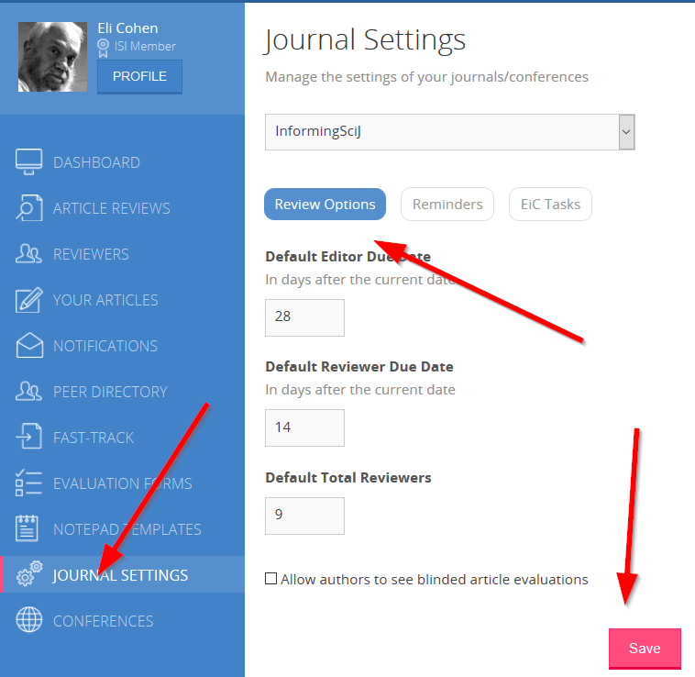
Figure 39. Typically, you will not change the Journal Settings

Overview of your menu tabs at http://My.InformingScience.org
The Dashboard tab has information about the status of submitted articles, the number and status of the journal’s reviewers, and copies of notifications that the system emailed to you. Click on the red numbers to access details of each category of paper. It is important to check your dashboard regularly to keep an eye on papers currently Pending and to act on those Delayed.
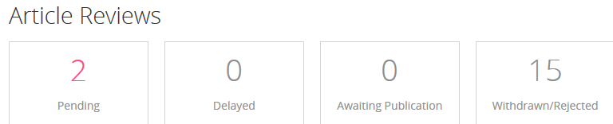
The Article Reviews tab gives you direct access to all articles in the review process.

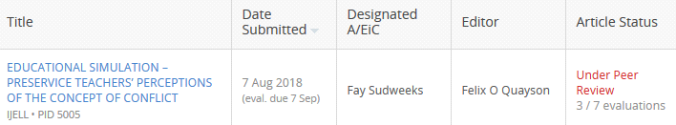

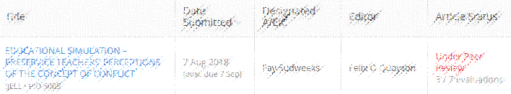
The Reviews tab has both a list of your journal’s reviewers and editors. You can toggle between the two lists.
The Your Articles tab lists your own articles, both pending and completed (see Figure 9).

The Notifications tab has a copy of all “official” emails sent to you from the Executive Director and the Governors. Click on the red Read More tab to read the full message.
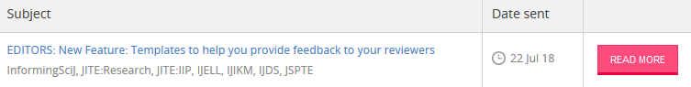
The Peer Directory tab searches ISI profiles to find people with similar research interests as yours.
Check this Fast-Track tab when the conference organizers advise that there are articles to fast-track from the current conference to your journal.
The Evaluation Forms tab enables you to manage the questionnaires to be completed by reviewers. Your journal is pre-loaded with evaluation forms selected by you or a former EIC from the Master List. You can create new Evaluation Forms, so you are not limited to those already in your drop-down menu. This page shows both the forms you create and those created by others that you have adopted. You can clone any form and tailor this copy to your own needs.
The Notepad Templates tab holds copies of Best Practices letters. You can add new templates, but be careful to use wording that is consistent with ISI’s philosophy of mentoring authors, reviewers, and editors.
The Journal Setting tab is where you can change the default settings for editor and reviewer due dates and the number of reviewers to be selected (see Figure 23 and the advice on changing settings).
The Conferences tab has links to the upcoming InSITE conference and recent InSITE conferences you have attended.

Instructions for checking Editors to be listed in ToC
Instructions for checking Editors to be listed in ToC (Table of Contents)

1. Login to ISI account

2. Select "Reviewers" on the left-hand menu.

3. Select "Editors"

4. Select desired journal.

5. Under "Export to Excel", select "Stats for selected journal" (at the bottom of the page) and click on the "Go" button.

6. In the downloaded Excel file, check the "Total Reviews Assigned Past 12 Months" and "Total Completed Reviews Past 12 Months" columns.
Notes:
- * Although the column titles mention "reviews" these are actually manuscripts that have been "edited".
- * If the "Total Reviews Assigned Past 12 Months" is zero, the editor should not be listed in the Table of Contents for that year.
- * It is possible that the "Total Completed Reviews Past 12 Months" is greater than "Total Reviews Assigned Past 12 Months" as the editor many have completion an assigned editorial from the last calendar year in the current year.

System Generated Emails

Notification to EiC that Editor has reviewed revised article
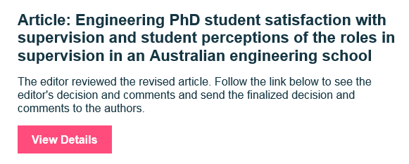

Reminder to Author to submit revised paper
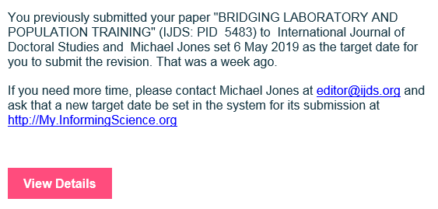

Reminder to Reviewer to review assigned paper
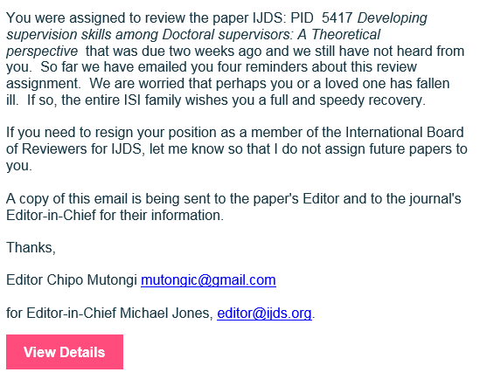

Supporting Membership
Encourage your colleagues with a research budget to become Sponsoring Members when they join or renew (Figure 44). The membership fees keep the lights on. For programming simplicity, existing regular ISI Members can switch to Sponsoring starting 30 days before the expiry of the regular ISI Membership.
Figure 40. Regular and Sponsoring ISI Member fees

Thank you
Thank you for your service to the academic community and for being a leader in improving the ISI journals. Some journals focus on rejecting as many papers as they can, others on accepting almost all. Our journals’ mission is to help all authors and reviewers to improve their craft as researchers. We do this by getting like-minded people together to mentor each other. As an Editor-in-Chief, you are a leader, guide, and coach for editors, reviewers, and authors.

